

CHAPPAQUA AYSO

COACHING MANUAL
2005-2006
TABLE OF CONTENTS

[TO COME]

Chappaqua AYSO
Coaching Manual

INTRODUCTION

Dear Fellow Coach,

CONGRATULATIONS! As a youth soccer coach, you are about to enjoy a rare privilege - becoming a
surrogate parent to 5 to 18 kids who are looking to have fun and learn the game of soccer.

With youthful exuberance and enthusiasm, the seven-year-old player finds challenges, excitement, and
fun with his or her classmates and friends on the soccer team. For the prospective coach, who likely has
never played the sport, the task of organizing a team, understanding the rules, running effective and
enjoyable practices, and making a positive experience of the Saturday (and or Sunday) game, is another matter. But just as your child player will develop soccer skills over time, the parent-coach can learn age-appropriate and
effective coaching techniques over time as well.

The members of Chappaqua AYSO, who have compiled this manual, believe that
your educated participation is vital to the overall experience of your players. We offer this manual to
our family of youth soccer coaches with the expectation that you will use it in conjunction with the full
complement of coaching clinics supported by AYSO. We hope that together these
resources will give you the confidence to be the BEST - for your child, your team, and the sport of
soccer.
COACHES, WE NEED YOUR HELP!

As you work with this manual during the season, please submit any suggestions that you might have
regarding improvements, clarifications, or additions:

• ADDITIONS: ________________________________________________________________________________________________________________________________________________________________________________________________________________________________________________________________________________________________________________________________________

• CORRECTIONS:
________________________________________________________________________________________________________________________________________________________________________________________________________________________________________________________________________________________________________________________________________

• TOPICS YOU WOULD LIKE TO SEE EXPANDED:
________________________________________________________________________________________________________________________________________________________________________________________________________________________________________________________________________________________________________________________________________

Please forward your ideas to us at the following address:

Scott Krase
48 Algonquin Drive
Chappaqua, NY 10514

Or

krasefamily@optonline.net

In addition, if you have a favorite skill game that has worked well for you, please send it to us along
with a diagram and description, plus a brief statement of the objective(s) and coaching points. We will
add them to future editions.

Thank you, and GOOD LUCK!
AYSO MISSION & VISION STATEMENT

Organization's mission is to develop and deliver quality youth soccer programs where everyone builds positive character through participation in a fun, family environment based on the AYSO philosophies:
Everyone Plays | Our goal is for kids to play soccer. So we mandate that every player on every team must play at least half of every game.
Balanced Teams | We require every region at the start of each season to set up teams as evenly balanced as possible - because it's more fun when teams of equal ability play.
Positive Coaching | The way to make winning kids is by building them up, not down. We train and encourage our coaches to make the extra effort to understand and offer positive help to our players, rather than negative criticism.
Open Registration | Our programs are open to all children between the ages of 4 1/2 and 18 who want to register and play soccer. Interest and enthusiasm are the only criteria for playing.
Good Sportsmanship | We desire to create a positive environment based on mutual respect, rather than a win-at-all-costs attitude. All our programs must be designed to instill good sportsmanship in every facet of AYSO.

The core values which guide the American Youth Soccer Organization are:
Fun for all
Education for all
Ethics for all
Accessible to all
The mission is accomplished by providing these essential services:
- Coaching and referee programs including quality delivery systems
- Quality administrative and operating systems with a support network
- Strong financial position
- Special network for volunteers, supported by a national staff
- Program research and development

Character Counts!
AYSO is a coalition member of the Josephson Institute of Ethics, and is committed to supporting the Character Counts program.
Its Six Pillars of Character are:
Trustworthiness
Respect
Responsibility
Fairness
Caring
Citizenship

AYSO COACHING REQUIREMENTS
FALL 2005 / SPRING 2006
Fill out the Chappaqua AYSO Coaching Request Form. This will help us assign your request to the appropriate division coordinator(s).

1) AYSO Safe Haven – available online at our website or offered in the area during the summer. Safe Haven teaches the basics of working with children under the guidelines of the Child and Volunteer Protection Act. Volunteers must complete Safe Haven to be covered by AYSO’s supplemental insurance.

2) AYSO Age Appropriate Certification – offered in the area during the summer. These classes teach coaching basics, including lots of fun practice games to play with your team. AYSO requires that an age appropriate coaching class be completed every 2 years. SuperCamp, which is usually at Mary Knoll in August, is a great opportunity to improve your coaching skills, with courses taught by AYSO’s national coaching staff.

Fill out eAYSO Volunteer form – fill out on line at www.eAYSO.org, sign and send to AYSO PO Box 113, Chappaqua, NY 10514. All volunteers must be registered in the eAYSO database in order to sign up for the Age Appropriate Certifiaction.

We’ll provide information via e mail and the www.chappaquaayso.org website on when and where classes are offered.

3) NYSCA – offered in town during the summer. The Town of New Castle requires all coaches and assistant coaches to take the National Youth Sports Coaching Alliance certification classes. For uncertified coaches, this is a two evening commitment of about 2 hours each night. Coaches participate in a video driven discussion on coaching children and another on teaching soccer skills. For coaches NYSCA certified in another sport, only the soccer specific discussion is required. Chappaqua AYSO will pay for the initial year’s membership and coaches must renew their own membership annually thereafter.

4) Background Check – Beginning with the spring of 2005, the Town of New Castle has instituted a mandatory background check for all coaches and assistant coaches. The background check consent form is available on line at this link New Castle Background Check Consent Form (required for Coaches and Assistant Coaches). Send the form with a check for $15 to the New Castle Department of Parks and Recreation, 200 South Greeley Avenue, Chappaqua, NY 10514. If you already filled out the form for another sport this past spring, then you do not have to do it again for soccer.

For additional information on coaching, contact our Regional Coach Coordinator Scott Krase at skrase@ohpny.com or 914-238-2126.

Thanks for volunteering to coach. We appreciate the time that you dedicate to fulfilling these requirements and to coaching. If there is anything we can do to help, let us know.

CONTACT INFORMATION

OUR WEB SITE: chappaquaayso.org
AYSO Hot Line: 238-3145
(this is announcements only - email is the best way to reach us with questions)
AYSO Mail: PO Box 113
Town Rec. Dept: 238-2540
CHAPPAQUA AYSO GENERAL INFORMATION
Chappaqua AYSO
PO Box 113
Within AYSO we are: Section 3 - Area 3T - Region 139

Senior Board Members | Contact | Email
Commissioner | David Perlmutter | david@perlmutterproperties.com
Assistant Commissioner | Dennis Greenberg | dgreenberg@Dearborn.com
Assistant Commissioner | Larry Grob | laurence.grob@zurichna.com

Division Heads | Coordinator | Email
U16 | David Wolfson | sonwolf33@yahoo.com
U14G | Charlie Steinhorn | steinhorn@vassar.edu
U14B | Tom Pile | tpile@audible.com
U12B | Marc Citrin | mci6301585@aol.com
U12G | Sandy Bologna | sbologna@cisco.com
U10B | Larry Grob | laurence.grob@zurichna.com
U10G | Forrest Sussman | Forrest.Sussman@thomson.net
U8B | Richard Zandi | richardzandi@yahoo.com
U8G | Peter Burack | pdb@burackinvestments.com
U7B | Ron Jendzejec | Rjendzejec@Bankofny
U7G | Lauren Stern | sternlaur@aol.com
U6B (K) | Chris Kramer | Chris.Kramer@us.tel.com
U6G (K) | Donna Levitz | dlevitz@optonline.net

Other Board Roles | Contact | Email
Auditor | Alan Pollack | alan.b.pollack@citigroup.com
Child VPA | Noah Sorkin | noah_sorkin@prusec.com
Coaches – Director | Scott Krase | skrase@ohpny.com
Communications – Director | Trisha Kallman | trisha@kallman.name
Extra Program – Director | Tom Pile | tpile1@mac.com
Field Coordinator | John Re | jre@agrylaw.com
Goal Safety & Maintenance | Richard Zandi | richardzandi@yahoo.com
Health, Fitness and Nutrition | Eric Small | sportsdr@yahoo.com
Newsletter Editor-in-Chief | Paul Leibowitz | paul@leibowitzny.com
Referees – Director | John Barnes | john.barnes@rbcdain.com
Registrar | Dru Welburn | dru@ivmost.com
Safety & Equipment | Marc Reisch | reisch@optonline.net
Secretary | Bruce Cheriff | bjch007@aol.com
Treasurer | Joel Wolf | wolfj@deshaw.com
Volunteer Coordinator | Dennis Greenberg | dgreenberg@Dearborn.com
Webmaster | Dru Welburn | dru@ivmost.com
Advisor | Jane Sheinfeld | Jfsheinfeld@aol.com
Advisor | Steve Adnopoz | sadnopoz@HarrisBeach.com
Advisor | Stu Finkelstein | sfinkels@skadden.com
Advisor | Steve Young | styoung@ccsd.ws
Advisor | Robert Snyder | Rsnyder@town.new-castle.ny.us
Commissioner Emeritus | John Re | jre@agrylaw.com
Commissioner Emeritus | Jay Shapiro | Jay.Shapiro@kmzr.com

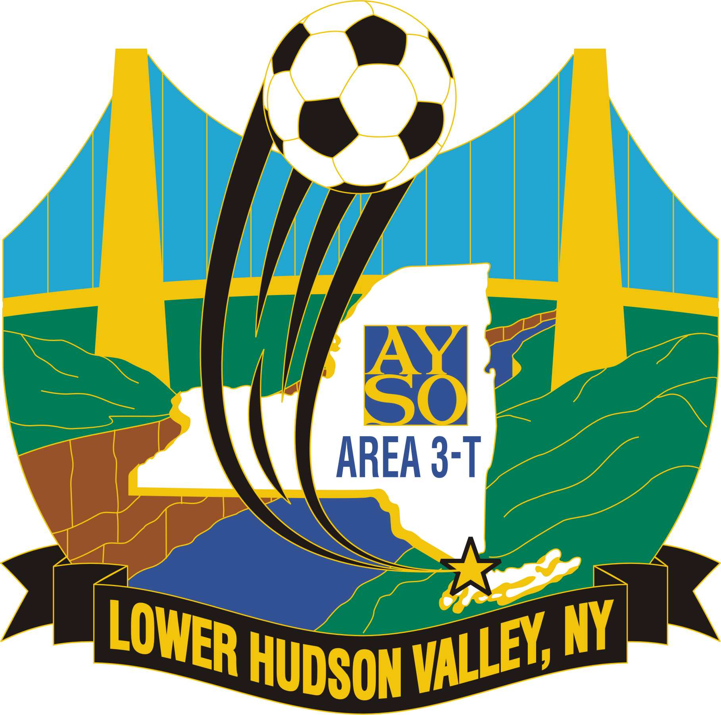


FIELD MAPS

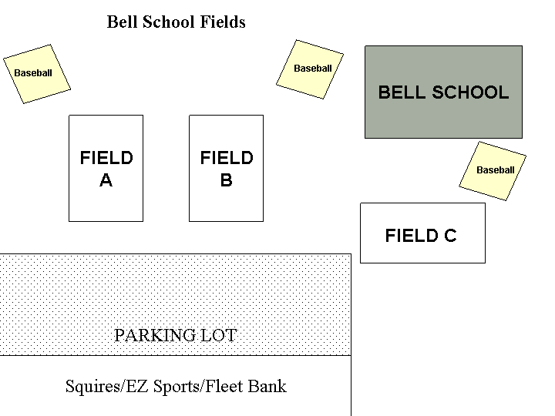

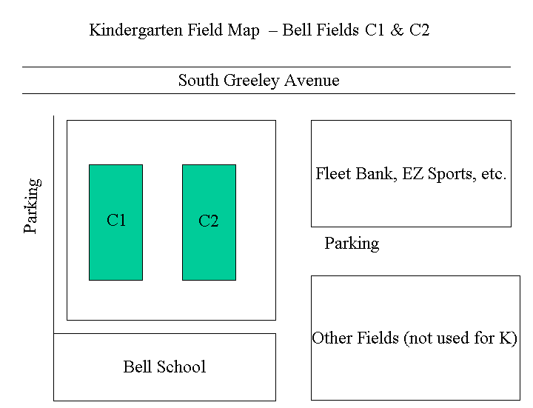

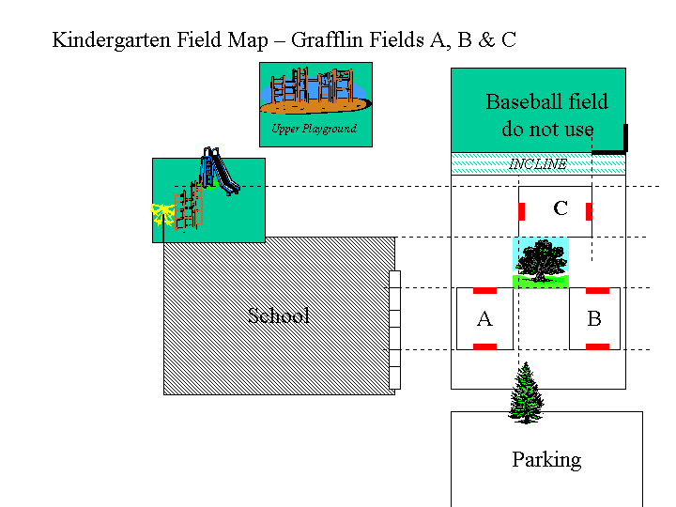

** NOTE: WE ACTUALLY ARE ALLOWED AND DO USE THE BASEBALL FIELD
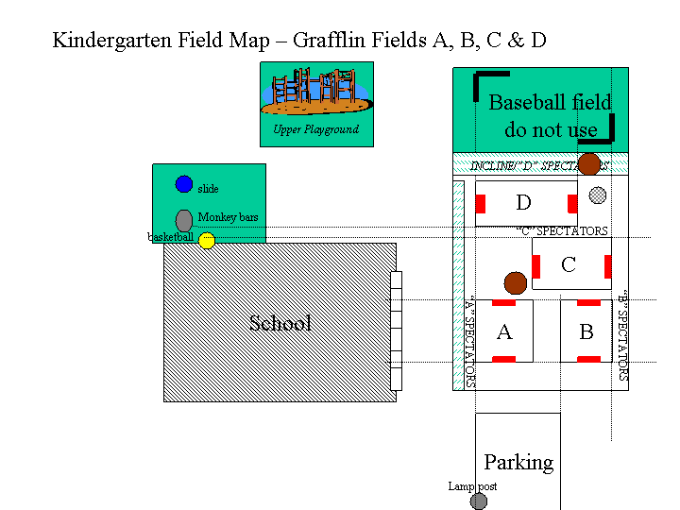
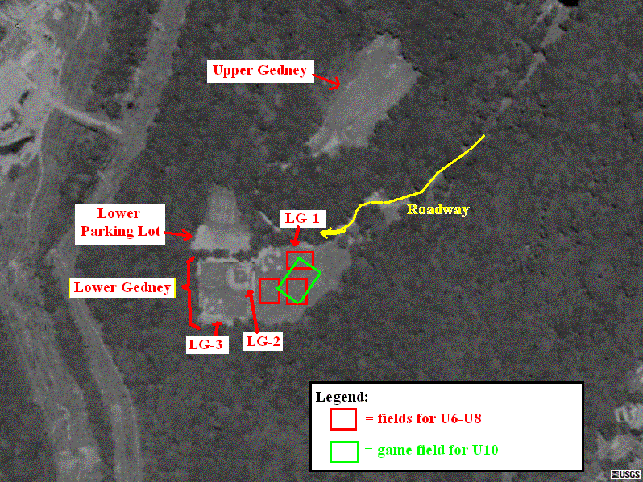
Field Map for Horace Greeley High School
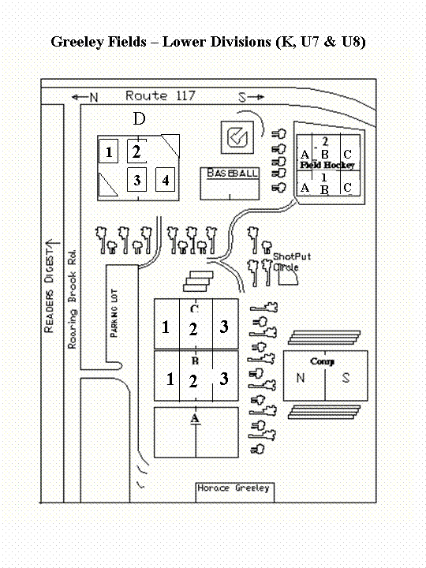

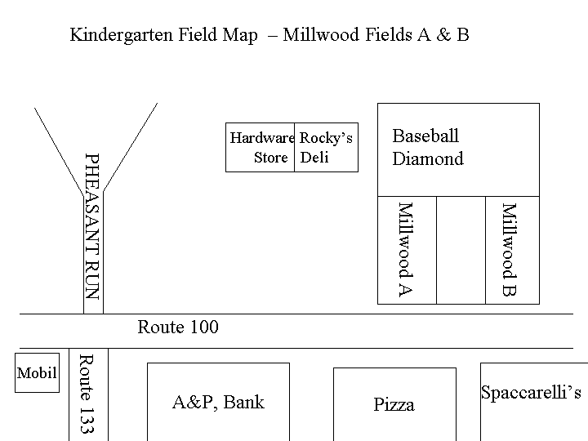

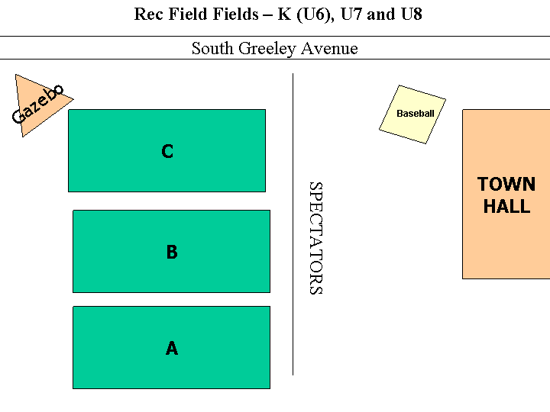
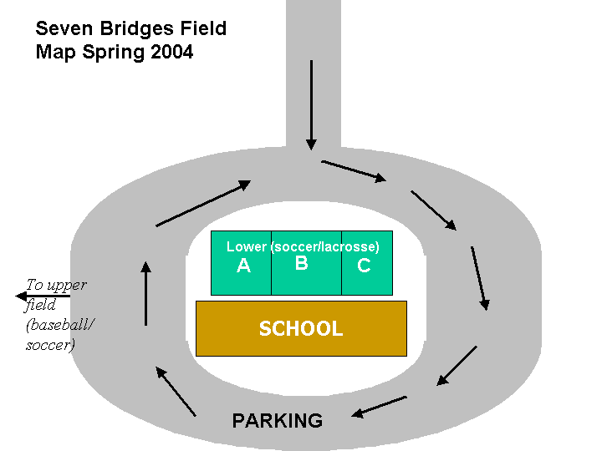
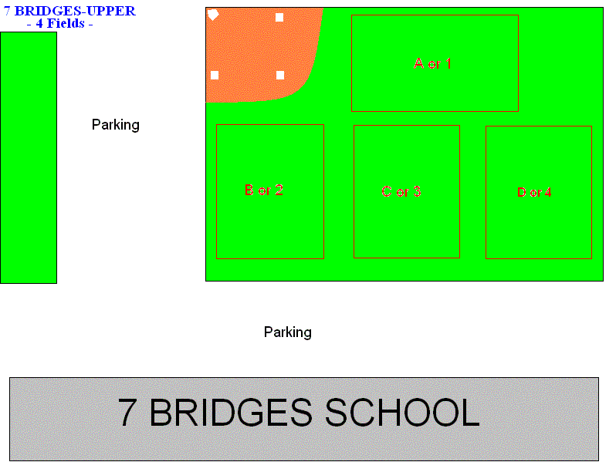

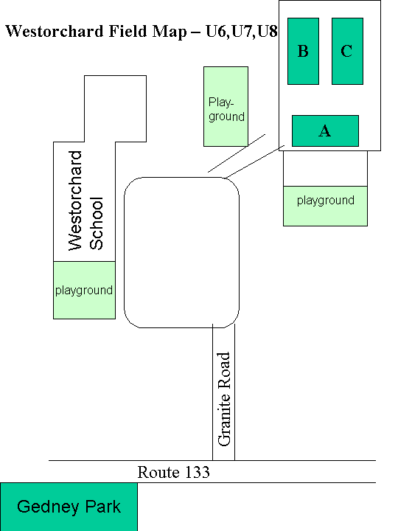
PLANNING FOR THE SEASON

Planning

The way to have successful practices is to plan. Your practice planning should begin before you first get
together with the team and should continue throughout the season as you plan for each practice.

Parent Orientation Meeting

All coaches are encouraged to establish effective lines of communication with team parents early in the
season by holding a parent orientation meeting. This may take the form of a casual discussion in your
living room, could be combined with a team picnic, or at your 1st practice. Whatever the format, the
time you invest will pay benefits for all concerned throughout the season. If a meeting is impossible, the
following information could be put into a letter to parents/players, but a face to face meeting is
preferable.

Purposes of a parent orientation meeting include the following:
• Enables parents to understand the objectives and goals of the program
• Enables parents to become acquainted with you, the coach
• Informs parents about the nature (and inherent risks) of the sport
• Informs parents of your expectations of them and of their child
• Enables you to address any concerns of the parents
• Establishes clear lines of communication between you, parents, and players
• Allows you to obtain parental support (assistant coaches, team parents, etc.)

Things to consider when organizing a parent orientation meeting:
• Hold it early in the season; preferably before the first team practice.
• Having the players present is optional.
• Prepare any handouts you would like to distribute, for example:
° team roster (with names of parents and players, telephone numbers)
° schedule of practices and games
° club rules
° team goals/rules
° summary or outline of the meeting
• Be prepared and be organized to conduct the meeting efficiently.

Important points to cover in your meeting:
• Coach introduction
° Introduce yourself and assistant coaches (or ask for volunteers at this time)
° Give some background information about yourself (why you are coaching,
experience)
• Coaching philosophy
° Discuss what you consider to be the value of this sport
° Discuss your methods for teaching skills (describe a typical practice)
° State the importance you assign to having fun and developing skills
° State the importance you assign to winning and losing
° Discuss any team rules and guidelines, disciplinary procedures
° Discuss your philosophy regarding player rotation, substitution, playing time
• Specifics of the program
° Practice schedule (how many per week? how long?)
° Game schedule (how many? when do they begin?)
° Minimum playing time (what is the rule in your local club?)
° Equipment required (e.g. shirts, socks, shorts, shin guards)
or recommended (e.g. ball, soccer shoes, water bottle)
° Inherent risks (soccer is a contact sport, albeit a relatively safe one)
° Medical insurance
• Team management

° Ask for volunteers as team parents (snack schedule, help with nets/flags)
° Set up telephone tree

Discuss COACH’S responsibilities, for example:
• Demonstrate leadership and good sportsmanship
• Treat each player fairly
• Have organized practices and teach soccer fundamentals appropriate to the age group
• Provide a safe environment (e.g. arrive at practice on time and remain after practice until
every child is picked up by an authorized adult, ensure that the players’ equipment conforms
to the club guidelines)
• Contribute positively to the development of each player’s self-esteem
• Help each player set individual and team goals that are realistic
• Give parents a schedule of practices and games in a timely fashion
• Allow each player to play half of every game at a minimum
• Respect the referees, know the rules, and conduct yourself in a controlled manner on
the field

Discuss PLAYER’S responsibilities, for example:
• Attend practices/games regularly, and to arrive on time
• Bring proper equipment to each practice and game
• Inform the coach in advance if it is necessary to miss a practice/game
• Make each practice a challenge to improve
• Work toward good sportsmanship and teamwork
• Respect the referees
• Be supportive of all teammates all of the time

Discuss PARENTS’ responsibilities, for example:
• Safety of the child may not transferred to the coach or other party
• Transport the child to and from practices/games on time
• Be supportive of all the players (criticism does not improve performance)
• Help the child understand that he/she is contributing to a team effort
• Focus on mastering skills and having fun, not on winning
• Avoid material rewards for the child (the reward is the fun of playing!)
• Attend games and cheer the team
• Refrain from criticizing opponents; be positive with all the players
• Respect the referees (they will make mistakes, but they are doing their best; if you feel
you are better qualified, see your club’s Referee Coordinator - he or she could easily find
work for you!)
• Refrain from coaching any child during games (try to understand and respect the
difference between the roles of the coach and the parent)

Answer any questions from the parents.

Suggestions for Dealing with Parents

Coaching is exciting and rewarding, but occasionally you may experience difficulty with parents. Some
parents may want their child to play more, others may question your judgment as a coach. Whatever the
concern, a parent is generally just looking out for their child, often at your expense. Don’t be
discouraged. There are some things you can do to open up communication and make dealing with
parents a positive aspect of your coaching duties.

1. Have a parent meeting before the first practice to discuss your plans and expectations for the
season. See the section: “Parent Orientation Meeting” for tips on how to do this well.
Encourage questions from the parents and let them know that you have given a lot of thought to
the upcoming season.

2. Express appreciation for their interest and concern. This will make them more open and at ease
with you.

3. Always listen to their ideas and feelings. Remember, they are interested and concerned because
it is their children that are involved. Encourage parental involvement. (If you have a preference
for a certain time to voice these concerns, such as after practice, make this clear at the Parent
Orientation Meeting.)

4. Know what your objectives are and do what you believe to be of value to the team, not to the
parents. No coach can please everyone!

5. Know the club and game rules. Be prepared to abide by them and to explain them to parents.

6. Handle any confrontation one-on-one and not in a crowd situation. Try not to be defensive. Let
the parent talk while you listen. Often a parent will vent their frustrations just by talking. Listen
to their viewpoint, then thank them for it.

7. Resist unfair pressure. It is your responsibility as coach to make the final decision. This doesn’t
mean that you can’t still listen to parents.

8. Don’t discuss individual players with other parents. The grapevine will hang you every time.
Show the same respect for each player on the team that you want the parents to show toward
you.
9. Ask the parents not to criticize their children during practice or a game. Don’t let your players
be humiliated, even by their own parents.

10. Don’t blame the players for their parents’ actions.

11. Be consistent! If you change a rule or philosophy during the season, you may be in for trouble.
At the very least, inform players and parents of any change as soon as possible.

12. Most importantly, be fair! If you treat all players equally and with respect, you will gain their
respect, and that of their parents as well.

Remember that you will be dealing with all types of children, and with parents having different
backgrounds and ideals. The challenge for you as a coach is to address these differences in a positive
manner so the season will be enjoyable for everyone involved.
COACH RESPONSIBILITIES

Chappaqua AYSO considers good conduct by coaches, parents and children to be an extremely
important part of the soccer program. The referee is responsible for calling the game, but the coach is
responsible for the behavior of spectators and team members. Neither the referee nor the children
should be subjected to negative comments from anyone.

Coaches’ Responsibilities:
1. To deal with the children in a positive manner.
2. To lead by example, and to conduct themselves in a controlled manner on the field.
3. To limit sideline coaching - the players need the opportunity to play their own game.
4. To develop high self-esteem and help each player feel a part of the team.
5. To teach soccer fundamentals appropriate to the age group.
6. To attend a coaching clinic each year.
7. To provide a safe environment.
a. To arrive at practice on time and to not leave the field until each child has been picked up
by the authorized adult.
b. To have the Medical Release forms available at all times;
c. To ensure that the players’ equipment conforms to the safety standards established by
Chappaqua AYSO.

Players Responsibilities:
1. To arrive at practice and games on time.
2. To bring proper equipment to each practice and game.
3. To treat teammates and coaches with respect.
4. To play within the intent of the rules.
5. To tell the coach if they will miss a game or practice.

Parents’ Responsibilities:
1. Provide transportation to and from all practices and games ensuring that the player is prompt
not only in arriving but also in departure.
2. Lend the young players your support in a positive manner. Do not point out their mistakes,
leave that up to the coach; instead, emphasize their accomplishments and efforts.
3. Be positive. Never criticize
4. If unable to attend the practices or games teach children not to talk with or leave practices or
games with strangers.
5. Ensure child brings equipment to and from all soccer games and practices when appropriate.
6. Be available to kick the ball around with your child!
7. Avoid material rewards. Build the attitude that the rewards lie in the fun of playing.
8. Be a good listener. Make them feel important and let them know that they are contributing to a
team effort.

OVERVIEW OF SOCCER COACHING

Introduction
Focus your attention on the listed points for each technique as you observe your players. It is important
for your players to learn to practice techniques properly, but remember that this may take some time -
more for some techniques than others, and more for some players than others. Techniques are striking
or receiving the ball properly. Making a good pass with the proper part of the foot is technique.
Receiving a pass with a soft touch that settles the ball at the players feet is technique. Tactics are the
decisions the player makes. Weather to beat the defender, or pass the ball. To use a "wall pass", send
the ball deep, or a crisp pass to a teammate are tactics. Make sue you discuss these decisions with the
players so they will learn the proper decisions that will help their team. Again, be patient and be
encouraging, this takes time!

Coach Equipment
1) A large BAG for all of the items listed below!
2) Players' MEDICAL RELEASE FORMS - you must have these with you at all practices and games;
verify that the emergency information is there.
3) MEDICAL KITS - A simple kit for games and practices is a good idea for every coach. A kit should
include:
• Ice (and 'zip-lock' bags)**
• Band aids
• Vaseline
• Sterile pads
• Adhesive tape
• Elastic wraps
• Antibiotic ointment
• Bee sting relief ointment
** If you use chemical cold packs, be careful about applying them directly to skin; some types are
exceedingly cold **
4) PUMP and inflating needle - sometimes the game ball is as hard as a rock or too soft and may need a
little "tuning"; the same goes for the balls kids bring to practice.
5) SHIN GUARDS - a spare pair of old ones will cover for a forgetful player!
6) SPARE SHIRTS (2) for your goalkeepers - having two extra shirts of different colors (each
contrasting with your team shirts) insures that you will always have a keeper's shirt that contrasts
with the opposition colors.
7) GOALKEEPER'S GLOVES - an inexpensive pair is a useful addition to your game bag. They help
the player feel more comfortable when playing the position.
8) BALLS - if possible, have a good quality ball available at the game. This will serve for team warmups
and can be used as a game ball if none is provided. The leather or synthetic leather soccer balls
are best; avoid the hard plastic-skinned balls which are unpleasant to kick or head. Each player
should have his own ball and bring it to practice; but bring any old spares that you may have to
practice because someone is likely to forget theirs.
9) CONES or pylons (about a dozen) to set up small areas for practice drills, as obstacles for dribbling
drills, or to mark boundaries for a scrimmage field. Cones
of a different color (or with some added duct tape) will make a distinctive goal.
10) WHISTLE and a CLIPBOARD (for practice plans, medical release forms, substitution schedules)
are helpful items.
11) WATER should be available during practice and at the game. Have the players bring their own
water bottles (but keep an extra bottle in your bag or cooler for the occasional forgetful player).
Alternatively, have your team parent organize a schedule among the parents to provide water and
cups.
12) A simple SNACK schedule should be organized by the team parent for game days. Discourage
turning snacks into a financial hardship for some parents. Orange or apple slices, or seedless grapes
are good choices.

Player Equipment

BALL
Encourage each player to have his or her own ball and to use it often, not just during team practice.
Players will not derive maximum benefit from practice unless they each have their own ball for warmups
and individual drills.

Soccer balls come in a variety of sizes, each designated by a number:
• size #3 - smallest standard size, for the youngest players (U-6 to U-8 or K-2nd grades)
• size #4 - intermediate size, appropriate for U-9 through U-12 (3rd to 6th grades)
• size #5 - largest standard size, for U-13 to adult (7th grade and up)

Check with your coordinator if you are uncertain which size is specified for players in your age group.

SHIN GUARDS

An absolute requirement for games, should also be worn for all practices. The pull-on “legging” type
with foam padding protecting the front of the leg from ankle to shin is an excellent shin guard. Shin
guards with plastic inserts offer additional protection, especially for the older player. Consider wash
ability when selecting a shin guard. The shin guards should be completely covered by the socks.

SOCCER SHOES

Double check with divison coordinator but generally cleats are optional but recommended.

WATER BOTTLE (with identifying marks on it)

Fresh water should be available to your players at each practice and game. It is easier for the coach if
each player provides his or her own water bottle.

SHIRTS, SOCKS, SHORTS
All will be provided by the league to the players. Extras should be saved as spares.

Practice Sessions - Introduction

PLEASE NOTE: IN PREPARING FOR PRACTICE - WE HIGHLY ENCOURAGE THE USE OF:

BYTESIZECOACHING.COM

USERNAME:CHAPAYSO
PASSWORD: HORACE72

I. Warm-up 10 minutes

Each practice session should be started with a warm-up.
Dribbling games make the best warm-up. Use your imagination to improvise from the skill
games described below. Keep it "ball" oriented and fun.

II. Stretching 0-5 minutes

Follow the warm-up with a stretching session. Generally, players under the age of 10 do not
need to stretch. It is good to have them do a little stretching even at these early ages to develop
the habit. Have the players stretch their calves, thighs, hamstrings, Achilles tendons, and arms.
Hold each stretch for the count of ten and do not let the players bounce while they are stretching.
This is a good time to tell the players what they will be doing in their practice today.

III. Skill Games 5 -15 minutes

Utilize one or two skill games during each practice. Try and build each of your practices around
a particular skill (e.g. dribbling or passing). First demonstrate the skill to the players before
starting and then correct group and individual players' mistakes during the skill games. Try not
to be over corrective - remember, let the game be the teacher!

IV. Scrimmages 5-30 minutes

Complete your practice with a small sided game (i.e. 3 v 3, 4 v 4). Try to make the skill you
practiced earlier a "condition" of the game. For example, in a practice that emphasized passing,
the players of a small sided scrimmage must complete 2 or more passes before they can shoot on
the goal. Make the scrimmage as much like a competitive game as possible, utilizing the rules of
soccer modified for the appropriate age.
Ball Control

Practice all foot skills with both right and left feet.

Inside of the foot pass
1. Ankle locked
2. Foot slightly up at the toe
3. Thigh turned outward
4. Look up to establish eye contact with teammates
5. Connect with the middle of the ball just before the instep
6. Follow through (contributes to direction and pace of the pass)

Outside of the foot pass
1. Ankle locked
2. Foot pointing slightly downward at the toe
3. Leg swings across the ball
4. Ball should spin when kicked

Receiving a pass
1. Move toward the ball (don’t wait for it to come to you)
2. Inside or outside of the foot used most often
3. Foot surface first touching the ball should be withdrawn slightly on contact to take the
momentum out of the ball (“cushioning”)
4. Ball should not be stopped completely, but under close control
5. Redirect ball in front or to the side in anticipation of moving in that direction to pass or
dribble

Dribbling
1. Small controlled steps ... ball should be kept approximately 2-3 feet in front of you
2. Strike the ball with either the inside or outside of the foot (softly and not with the toe)
3. Look up frequently to see defenders and establish eye contact with teammates
4. Change speed and direction

Ball juggling
Continuous bouncing of ball off head, shoulders, thigh, foot, etc. without the ball touching the
ground . This will develop ball control asininities.

Shielding
1. Legs bent
2. Shoulders down
3. Arms at the sides
Used as a means of keeping an opponent away from the ball, or to stall for time waiting for a teammate
to get open for a pass.

Heading
1. Lean back at the waist
2. Lunge into the ball with neck stiff
3. Strike the ball with the middle of the forehead, below the hairline

Shooting
1. Head down
2. Let the ball come under the body (allows the shot to stay low)
3. Ankle locked with foot pointing downward at the toe
4. Strike the ball with the laces of the shoe
5. Accuracy before power (avoid shooting directly at the goalkeeper)

Throw-ins
1. Ball MUST pass directly over the head
2. Both hands must remain on the ball (R and L thumbs meet behind the ball; thumbs and
fingers of both hands form a W)
3. Both feet must be on the ground (not necessarily flat; it is permissible to drag the toe of the
trailing foot)
4. As soon as ball is released, player should get back onto the field (often to receive a return
pass)

“Trapping” (Settling or Controlling)
1. Controlling the ball using any legal part of the body (NO HANDS unless you are the goalie)
2. The controlling surface must “give” on contact to cushion the ball
3. Ball should stay close to the player (not bounce away)
4. If using a chest trap, bend the body backward slightly so the ball rolls down onto the ground
at the feet
5. Important when controlling the ball from the air to the ground, that it settle at your feet.
Keep the ball under the frame of the body.

Simple Soccer Tactics
Remember, tactics are not important for the U6-U8 player and should not be stressed. As the players
mature, and the concept of team play begins to develop, the tactical elements can be introduced. Listed
below are some basic guidelines for the coach, which fall into the realm of tactics.

General

• Play positions (the various roles can be understood even as players rotate positions).
• Get open and call for the ball.
• Look and listen for passing opportunities.
• Pass and move to space and/or to a support position.
• Work to build and maintain triangles - the basic structure for passing and support.
• Always support the player with the ball (forward and rear support within passing
distance).

Team Offense
• Maintain possession of the ball.
• Keep the offense wide in order to spread (and weaken) the opponents’ defense, and to
create space for scoring opportunities.
• Penetrate as deeply as possible with every pass, without unduly risking loss of
possession.
• Finish attacks with shots on goal.
Team Defense
• Support and communication are critical.
• Pressure opponents to decrease their “comfort zone”.
• Delay opponents’ attack when your team first loses possession of the ball, to permit
defense to regroup.
• Mark “goal-side” to defend against shots on goal.
• Mark “ball-side” to defend against easy passes.
• Maintain defensive balance on the field; guard against reversing the ball (crossing passes
to opposite side of field).
• Mark opponent tighter as you get closer to your goal.
• Concentrate defense in front of the goal as the ball approaches your goal, limiting space
available for shots on goal, and direct ball away from goal.

Kick off
• Short pass and dribble.
• Short pass and pass back (triangle).
• The ball must move forward on a kick-off.
• (Note that the “long boot” is not encouraged!)

Throw-in
• Throw to an open teammate if possible (first look for the farthest unmarked player).
• Throw toward the other team’s goal.
• Throw down the touchline.
• Throw to your goalkeeper (this is not considered an illegal pass back), but your keeper
cannot pick the ball up.
• Take throw-ins quickly (before the defense can set up) but always be under control.
• Throw the ball so that it can be controlled in the air.
• Thrower should re-enter the field quickly to be open for a return pass.

Goal kick
• Big kick up the side of the field.
• Avoid kicking the ball across the front of your goal.
• Consider having a defender take goal kicks while the goalkeeper maintains position to
guard goal (frequently used for younger players)

Free kick
• Close to goal, direct free kick- shoot at the goal, away from the keeper.
• Close to goal, indirect - short pass to teammate, and shoot at goal.
• Far from goal - big kick toward the front of the opponents’ goal.

Corner kick
• Bend the ball, as a goal may be scored directly from a corner kick.
• Big kick into the opponents’ goal area.
• Short pass and dribble or cross ball to far side of goal.

Drills (Skill Games) - General Guidelines

There are countless drills and many websites, books and videos are available.

WE HIGHLY ENCOURAGE THE USE OF:

BYTESIZECOACHING.COM

USERNAME:CHAPAYSO
PASSWORD: HORACE72

Some popular skill games are included here for your immediate use.
You don’t need 100 drills. Pick a few and work at them.

Step 1 - Explain the drill (why it is done, how it is done).
Step 2 - Demonstrate the drill (slowly, step-by-step).
Step 3 - Execute the drill.
Step 4 - Figure out what went wrong (it’s often the instructions); fix it, and start over!
Step 5 - Use assistance from pictures, videos, CDs or experienced coaches to demonstrate.
Remember: showing is better than talking.
Some drills will not work well at first. Maybe they need a small adjustment (e.g. too many players, or
players standing too close or too far apart).

Repetition of drills builds skills. It can also be boring. So use variations of drills, and don’t repeat the
same drill too often. If your players are not enjoying and not learning from a particular drill, find
another that focuses on the same skills.

Start a drill simply and progress to the harder stuff. For example, begin with a simple passing triangle;
then introduce a chaser.

Play with the kids! Sometimes you should join in the drill as a participant rather than as a coach. Not
only will the kids enjoy it, but you will gain a better appreciation of the skills you are asking them to
master. You can also control the intensity by your play.

IDEA: Call a parent from the sidelines to be goalkeeper for a shooting drill!

Experiment! Don’t be afraid to try new ideas.

Split the team into small groups for you and your assistants to teach a drill; then rotate. This keeps more
players busy and allows more individual attention.

When organizing the kids into small groups, consider their abilities. For example, in some dribbling or
passing drills it might be best to have pairs with similar abilities. Conversely, in competition (e.g. 2v2)
you might pair stronger and weaker players for balance.

Start a drill slowly. WALK through it first, then do it at half speed, and finally at full speed.

Skill Games

I. Dribbling
Beehive - Provide a 6-8 yd. x 6-8 yd. grid. Each player has a ball. Players dribble
inside the grid randomly using correct techniques and practicing avoiding other players.
Players should practice inside and outside foot dribbling, stopping, changing direction,
and maintaining control while in the beehive.

King of the ring - Provide a 10 yd. x 10 yd. grid where each player has a ball. One
player or the coach is "it" without a ball. Players start to dribble in the grid while trying
to avoid having their ball kicked out of the grid by the player who is "it". Players can
reenter the grid after retrieving their ball and completing some type of small skill penalty
activity, like juggling the ball twice on their feet or knees or dribbling around a nearby
tree before returning to the grid.

Red Light - Green Light - A traditional game where the players dribble their balls
forward and must learn to control and stop their balls on the "red light" command. Line
all the players up and have the coach be the traffic cop. Send out of control players back
to the starting line.

Attack and Protect - Provide a 10 yd. x 10 yd. grid. Each player has a ball. Players
dribble around in the grid trying to kick another player's ball out of the grid while at the
same time protecting their own ball. Provide the players with a skill "condition" that they
must complete before they may reenter the grid.

Spiderman - Provide a 15 yd. x 15 yd. grid. Each player should have a ball. The
coach starts as the first spider. The players dribble around the grid while trying to avoid
the tag of the spider. When a player is tagged by the coach, they join hands and go after
new prey. Each successive tagged player makes the web of the spider grow bigger, but,
alas, less organized. Young players will request this game constantly.

II. Passing

Keep Away Circle - Players pair up and stand across from each other around a circle
of cones. One player or the coach stands inside the circle and tries to intercept passes
made between the players. Passes completed between partners count as goals. Change
the player inside the circle after a pass is intercepted or after a short time interval.

Cone Game - Players pair up and stand across from each other around a circle. Set up
6 or 8 cones in the middle of the circle as targets. Partners try and knock over the cones
in the middle with accurate passes.

Triangle Pass - Set up a three player triangle. Each group has one ball. Players pass to
each other around the triangle shape. Make sure they reverse the direction of their passes
from time to time. After a certain level of proficiency is reached, add a defender to the
center of the triangle who will try to intercept the ball.

Four Corner Pass - Set up a 10 yd. x 10 yd. grid with cones at each of the four
corners. Four players work with one ball, one player on each side of the grid. A fifth

player defends inside the grid. Players may only run between the cones on their side of
the grid as they attempt to pass the ball across the grid. Change the middle player often
to keep the play crisp and fast.

Star Wars - This competitive game is very exciting for younger players! Set up a 10
yd. x 20 yd. grid. Have all the players line up at one end prepared to run to the other end.
The coach or a player stands just outside the grid at midway with several balls at the
ready. On command the players attempt to run to the endline while evading balls kicked
at them by the coach. All shots should be kept below waist level. Players hit by the balls
become new additional shooters until only one runner is left.

III. Shooting Drills
Marbles - Players are organized into pairs, each with a ball. Standing with his back
to the field of play, the first player throws his ball over his head. The second player then
kicks his ball from the starting point and tries to hit the ball that was thrown. Play
alternates by kicks until one ball is hit. The players then reserve and start again. Coaches
should emphasize instep kicks for length and side of the foot kicks for accuracy. Make it
a condition that every other game is left foot only!

Four Goal Game - Set up four cone goals about two yards wide in each corner of a 20
yd. x 30 yd. grid, Divide players into two equal teams. Players may score at any of the
four goals. This game encourages teamwork and results in lots of shooting.

Shoot Between Cones - Set up a cone row with cones spaced 3 to 5 yards apart. Pair
up players and position one player on each side of the cone row facing the cones and each
other. Players should start close to the row of cones at first, striking the ball between the
cones. The partner receives the ball and strikes it back between the cones. Move players
farther away from the cones as their technique and accuracy improve.

Go For Goal - Players form two lines on either side of the coach who is standing about
18 to 20 yards from a goal of any size. The coach serves the ball toward the goal while
one player from each line races to win the ball and shoot. As skills progress, add a
goalkeeper. The coach should encourage correct shooting technique and a good first
touch on the ball.

Dribble Cones and Shoot - Set up two cone lines for a dribble weave about 30 yards
long with a 2 yard goal at the end. Divide players into two lines or teams. Players must
dribble through the cones and score at the goal at the end before the next player in line
starts.

IV. Other Games
The Numbers Game - Young players will play this game for hours! Set up a 10 yd. x
20 yd. grid with goals at each end. Divide players into two teams and place each team on
one of the end lines. Number the players 1 - 6 (or use colors for very young players).
The coach stands at the halfline and serves a ball into the grid while calling a number.
Players who are called sprint off their end line to win the ball, play 1 v 1, and try to score.
Players standing on the end line may keep the ball in play but may not protect the goal.
The coach could try 2 or 3 numbers. Ball should be served on the ground.

3V3 or 4V4 Pass and Strike - Set up a 10 yd. x 15 yd. grid with two opposing goals. Divide
players into two teams. Players must pass the ball to each team member or make 4
complete passes before they can shoot on goal. If the ball is taken by the opponent the
team must start over in its pass count.

Crab Soccer - Set up a 10 yd. x 15 yd. grid with goals at each end. Divide the players
into two teams. Players must walk on their hands and feet simultaneously while trying to
pass the ball to teammates and scoring. This game really encourages teamwork because
of the difficulty in movement by the players.

Scrimmages - General Guidelines

General:
• Not the best for improving skills (many players, only one ball). But the kids love scrimmage
and its great fun for them. So allow plenty of time for scrimmage during every practice, but
don’t make it the only activity.
• Excellent for learning positions and game simulation.
• Good way to teach the rules (you are the referee!), but try not to stop play too often.

Small-sided scrimmage:
• Fewer players, thus each player gets more touches on the ball.
• Small field and small goal requires more control and passing.
• Small goal encourages accuracy.
• HIGHLY RECOMMENDED IN PRACTICE FOR ALL AGES!
• If you have a large team and sufficient space, run two games simultaneously.

Scrimmage with conditions:
• Maximum 5 touches: to encourage passing.
• Minimum 2 touches: to encourage control (no one-touch “passes”).
• Minimum 5 touches: to encourage dribbling.
• Must pass 3 times before allowed to shoot: rewards passing and good spacing.

Uneven scrimmage:
• 5 v 2 or 4 v 2 with no goals: forces passing. (The larger team counts passes.)

Offense vs. Defense:
• Good to practice action at the mouth of the goal.
• Good to work on set plays (goal kicks, corner kicks, free kicks).
• Have 2 or 3 extra players on offense to keep the action around the goal.
• Give defenders two small goals near the touchline at midfield.

Freeze!
• Blow the whistle and call “freeze”.
• All players must stop where they are.
• Coach makes observation, e.g. players open on right flank.
• Excellent teaching tool (if not used too often).

Open scrimmage:
• Full game simulation.
• All players, one game.
• Enforce rules more strictly to encourage fair play; it also gives players free kick practices.
• Play another team occasionally, if possible; practice subs and positions.

Coaching 3v3

U6 - Kindergarten

Soccer Techniques

Five year olds should have fun and develop an appreciation for the game of soccer. The field is small,
20x30 yards, and goals are not protected, except for the field players of the opposing team. The theory
is to allow the players to dribble and shoot the ball as much as possible. Players are usually arranged in
a triangle, which allows for passing, but do not be concerned if this does not happen. Allow them to
have fun, and training should be in getting them to go the proper direction, striking the ball properly
with the foot, and how to defend.

Listed below are some techniques which you can reasonably expect to introduce to kids by the time they
are six years old. The major emphasis for the youngest players should be on getting comfortable with
the ball while introducing basic techniques. “Coaching” should be kept to a minimum; teach through
enjoyable games and exercises. Allow the game to be the teacher. Tactics are not important at this age.
Be patient!

Start practices with warm-ups, using a ball whenever possible. This age does not need to stretch

You should be aware of skills the players will need at the next age group, so you can help the
exceptional player advance.

The Game

Play Formation

Place 3 players in a triangle. The goal is to have them sort of resemble that shape during play. The
triangle may have 2 players forward and one behind, or 1 forward and 2 behind.

Length of Game

1. Games will consist of 4 equal 5 minute quarters with a 1 minute break between quarters and
a 5 minute half time break.

2. The clock is not stopped during the game.

Substituting

Substitutions should be made at the end of each quarter. Each coach should determine a system of substituting
Which allows for no one player to play two quarters more than anyone else. BE FAIR!!!

Switching at Half Time

After the half time break, the players switch ends of the field.

Goals

There are no goalkeepers in 3v3 soccer. The intent is for the kids to be encouraged by the success of
scoring goals. All free kicks are indirect kicks, meaning that two players must touch the ball before a
goal is scored off a free kick. Goals cannot be scored directly from a free kick, goal kick, corner kick, or
throw-in. A second player, from either team, must touch the ball before the goal can be scored.
Coaches are asked not to keep score.

Equipment

1. U6 uses a size 3 soccer ball.

- Players are responsible for providing their own equipment. Players may wear cleats. All players must wear shin guards during practice and games. Shin Guards must be covered by socks. All players on the team should be attired in matching jerseys.

3. No ear-rings, watches, rings, necklaces, bracelets, wristbands or casts may be worn during game
play or during practices. Hair bands, if used, must be elastic, with no balls on them. Any other
articles, which in coaches or referee opinion, may endanger the player or other players, are also
not allowed. Pierced earrings may not be worn, even if taped.

4. Splints, casts, or braces with hard components may not be worn. Soft, elastic bandages may be
worn provided the ends are taped to cover metal clips.

Restarting the Game

1. When the ball goes out of play, restart in the following way:
a) Over the touchlines - restart with a throw-in (shall be retaken if not properly done). The
ball is out of play, only when the entire ball passes over the entire side line. Players
need not be on the field to play the ball. The ball must be on or inside the lines to be in
play.
b) Over the goal line, but not in the goal, last touched by the attacking team - restart with a
goal kick; all opposing players must stand at least 5 yards away from the ball;
c) Over the goal line, but not in the goal, last touched by defending team - restart with a
corner kick; all opposing players must be at least 5 yards from the ball.

2. After a goal is scored, restart with a kick-off; all opposing players must be on their own half of
the field. Defending players must be outside of the center circle

3. Restart with a drop ball if:
a) The referee did not see who last touched the ball;
b) The game is stopped because of an injury.
(1) A drop ball is between two players. All other players should be 5 yards away from
the ball drop. The ball must touch the ground before either player touches it. It is
safer for the players, if the ball is rolled slightly away from them as it is dropped.
The players are least likely to kick each other while trying to kick the ball.

NOTE: We have lately been restarting “automatically” in U6 for the fall session with a second ball being thrown into play immediately. Please check with your division coordinator!

Coaching 4v4

U7 1st graders

Soccer Techniques

Six and seven year olds should have fun to develop an appreciation for the game of soccer. At this age
group, there still is no goal keeper, but there may bea goal box in front of the goal. The goal box is a no-man
zone, where neither offense nor defensive players are allowed. The purpose of this is to encourage
shooting from a distance, and to encourage the defensive players to be involved in play rather than camp
in front of their goal.

Listed below are some techniques which you can reasonably expect to introduce to kids by the time they
are 8 years old. The major emphasis for the youngest players should be on getting comfortable with
controlling the ball and learning to pass. The 4v4 play provides a diamond concept which allows for
passing back as well as ahead and to the sides. “Coaching” should still be kept to a minimum; teach
through enjoyable games and exercises. Allow the game to be the teacher. Tactics are not important at
this age, but defining passing and defending should be emphasized. Be patient!

You should be aware of skills the players will need at the next age group, so you can help the
exceptional player advance.

The Game

Play Formation

Placing players in a diamond formation is available at this age. The diamond shape gives good strength
in the middle, and allows one player to move forward or back as needed. Another formation is a box,
with 2 players forward and 2 behind. This offers multiple triangles as well, but reduces the "pass back"
options.

Length of Game
1. Games will consist of 4 equal 10-12 minute quarters for U7, with a 1 minute break between quarters and a 5 minute half time break.
2. The clock is not stopped during the game.

Substituting
Substitutions should be made at the end of each quarter. Each coach should determine a system of substituting
which allows for no one player to play two quarters more than anyone else. BE FAIR!!!

Switching at Half Time
After the half time break, the players switch ends of the field.

Goals
Coaches are asked not to keep score.

Equipment
1. U7 use a size 3 soccer ball.
2. Players are responsible for providing their own equipment. Players should have soccer shoes or
turf shoes with molded plastic cleats, single toe cleats are not permitted. All players must wear
shin guards during practice and games. Shin Guards must be covered by socks. All players on
the team should be attired in matching jerseys.
3. No ear-rings, watches, rings, necklaces, bracelets, wristbands or casts may be worn during game
play or during practices. Hair bands, if used, must be elastic, with no balls on them. Any other
articles, which in the opinion of the referee, may endanger the player or other players, are also
not allowed. Pierced earrings may not be worn, even if taped.
4. Splints, casts, or braces with hard components may not be worn. Soft, elastic bandages may be
worn provided the ends are taped to cover metal clips.

Restarting the Game
1. When the ball goes out of play, restart in the following way:
a. Over the touchlines - restart with a throw-in (shall be retaken if not properly done). The
ball is out of play, only when the entire ball passes over the entire side line. Players need
not be on the field to play the ball, but the ball must be in play.
b. Over the goal line, but not in the goal, last touched by the attacking team - restart with a
goal kick; all opposing players must stand at least 5 yards away from the ball;
c. Over the goal line, but not in the goal, last touched by defending team - restart with a
corner kick; all opposing players must be 5 yards from the ball.
d. Dead ball within the goal box, restarted by an indirect free kick taken from outside of the
box by the team that did not last touch the ball.
2. After a goal is scored, restart with a kick-off; all opposing players must be on their own half of the
field. Defending players must be outside of the center circle
3. Restart with a drop ball if:
a. The referee did not see who last touched the ball;
b. The game is stopped because of an injury.
c. A drop ball is between two players. All other players should be 5 yards away from the
ball drop. The ball must touch the ground before either player touches it. It is safer for
the players, if the ball is roller slightly away from them as it is dropped. The players are
least likely to kick each other while trying to kick the ball.

SPORTSMANSHIP

Soccer - Ethical and Moral Credo

The Coach
1. Treats own players, parents, and opponents with respect.
2. Teaches and inspires soccer players to love the game and to compete fairly.
3. Demonstrates by example the type of person he/she wants the players to be.
4. Has control and commands discipline at all times.
5. Respects the interpretation of rules and judgment of the officials.
6. Realizes that as a coach he/she is a teacher and therefore understands the game and proper
soccer behavior at all times.

The Player

1. Treats opponents with respect.
2. Plays hard plays within the rules of the game of soccer.
3. Demonstrates self control.
4. Respects officials and accepts their decisions without gesture or argument.
5. Wins without boasting, loses without excuses and never quits.
6. Remembers that it is a privilege to represent his/her soccer club and community.

The Official

1. Knows the rules and understands the game.
2. Places health and welfare of the players above all other considerations.
3. Treats players and coaches courteously and demands the same from them.
4. Works cooperatively with fellow referees and linesmen.
5. Is fair and firm in all decisions on the field.
6. Maintains confidence, poise and self control from start to finish of the game.

The Parents

1. Do not coach the team players including your own youngster, from the sidelines during the
game.
2. Respect the judgment of the referee and do not criticize officials.
3. Supportive parents focus on mastering soccer skills and game strategies.
4. Decrease the pressure to win.
5. Believe that soccer’s primary value is to provide youth an opportunity for self-development.
6. Understand the risks. A soccer game is full of mistakes and the team that makes fewer
mistakes generally wins the game. Playing soccer is a willingness to chance failure.
7. Communicate with the coach and create a positive, supportive working relationship.
8. Understand and respect the different roles of parents and coaches.
9. Control negative emotions and think positively.
10. Avoid the use of fear - because player development is rarely fostered by fear of the
consequences of failure.
11. Parents must show empathy for the young developing soccer player.

Value Statement for Youth Sports

Youth sports programs provide an enjoyable learning environment for the physical, social, and personal
development of youngsters. The values of youth sports programs include:

• Promoting fitness
• Developing new skills
• Instilling a desire to succeed
• Teaching responsibility and commitment
• Teaching cooperation
• Preparing one to deal with success and failure
• Providing an outlet for the release of energy
• Building character through discipline
• Teaching how to cope with the realities of life
• Instilling positive attitudes toward authority
• Providing a fun and enriching experience

The likelihood that youngsters will realize positive sports values is enhanced when adult sports leaders
take the responsibility to serve as facilitators of desirable sports outcomes.
This can be achieved when coaches assume a role as teacher and carry out lesson plans which develop
skills progressively, emphasize positive sports values, and encourage life-long interest in sports
participation.

COACH LIABILITY AND PLAYER SAFETY

Liability and the Volunteer Coach†

As a volunteer coach you will have the care, custody and control of someone else’s children for 30-50
hours this season. In this capacity you have the potential both to create and to prevent accidents and
injuries.

You should be aware of your legal responsibilities as a coach. Attention to these duties will help
minimize your personal risk, prevent sports-related injuries, and avoid claims of coaching negligence.
Your legal duties include:

1. Providing adequate supervision (general and specific to the game) - The health and safety
of your team members are entrusted to your care. You must provide adequate supervision
to avoid foreseeable accidents and injuries. NEVER leave players unattended! NEVER
leave after a game or practice until all are safely picked up by parents or guardians!
2. Sound planning - Carefully plan your practices and drills so players progress and learn
new skills at a safe pace. Don’t move too rapidly by forcing improvement. Make written
practice plans and keep them on record for the duration of the season.
3. Warning players of inherent risks - Players and parents must know, understand, and
appreciate the risks they are likely to encounter in soccer. YOU MUST TELL THEM! (the
parent orientation meeting is the time to do this) Warn your players about potentially
dangerous techniques.
4. Providing a safe playing environment - Be certain that practice and playing fields are free
Of hazards (e.g. holes, rocks, broken glass or other debris) and that equipment (e.g. goal
posts) is in proper condition. Warn your players NOT to hang from the goal cross bar!
5. Evaluating players and determining any limitation regarding participation - Be sure
players are physically capable of performing the required skills. This includes mental,
physical, and even child abuse situations. Evaluate old injuries as carefully as you can
before letting players return to action.
6. Matching or equating opponents - Fairly match players for practices and games, giving
consideration to body weight, skill level, and maturity.
7. Providing proper first aid - Have a first aid kit available along with a plan which outlines
emergency procedures. Know where to find emergency help and a telephone (put a couple
of quarters in your first aid kit or have a cellular phone on hand). Don’t attempt to provide
aid beyond your qualifications. ALWAYS have your players’ medical release forms with
you - they should provide emergency phone numbers as well as permission for you to
obtain emergency medical aid in the event a parent/guardian cannot be reached.

Be aware of problems concerning transportation. Carry adequate personal liability insurance.
Accepting money for transportation may void your personal auto liability insurance - check with your
insurance agent or carrier.

Respect the civil rights of your players on and off the field. Consider the factors of the game as it
relates to officials and spectators. Keep good records of an event especially in the case of an injury.

Finally, it is to your advantage to have a second adult in attendance at your practices. This reduces the
risk that you could unjustly be accused of inappropriate behavior.
Coaches who successfully perform the above duties not only reduce their personal risk, but also
demonstrate to parents and other coaches a desire and willingness to act responsibly for the benefit of
the kids.
† (adapted from Glenn M. Wong, Sports Management Program, and University of Massachusetts)

Negligence and a Coach’s Legal Duties

The risks of the game (called inherent risks) are acceptable as long as a coach acts prudently and as long
as these inherent risks are known, appreciated, understood and consciously accepted by the participants.

NEGLIGENCE: The failing to act in manner that a reasonable and prudent coach would normally act in
a similar situation.

Four Factors in Determining Negligence

All four must be present to prove negligence:
1. The presence of a duty: Do you have a duty/duties to your players?
2. Breaching the duty: Failing to act necessarily, acting wrongly or acting properly but in a
wrong fashion.
3. Cause of the injury: Your breach of duty?
4. Extent of injuries.

Legal Defense

When charged with negligence there are defenses:
1. Assumption of Risk: Players must know, understand and appreciate those risks.
You must tell them.
2. Contributory negligence: The player acted negligently and contributed to the injury.
3. Comparative negligence: Negligence of both parties compared on a percentage basis.
Player cannot recover if his/her percentage is above 49%.
4. Other defenses: Act of God or technical defenses.

FIRST AID FOR SOCCER INJURIES

When you accept the role of coach, you accept a major responsibility for the care and safety of your
players. Although the athletes share in the responsibility for their protection and safety, their ability to
understand what they can do,, how they can do it, and whether they are doing it correctly, may be
limited. It is your job to help them practice and play as safely as possible.

The information below was adapted from the ASA/VIP Softball Safety Manual and the American Red
Cross First Aid Reference Guide (1990). It is designed to help you better care for your players; it is not
meant as a substitute for a first aid course. If you don’t already have first aid certification, we encourage
you to enroll in both CPR and first aid classes to help prepare yourself to handle accidents that may
happen while you are coaching.

Your job as a volunteer coach is to recognize an injury when it happens, to stabilize the injury as best
you can, and to summon medical assistance if necessary. You need to understand the limitations of your
training and knowledge. If you are not a trained medical professional, then it is your responsibility to
call one immediately whenever you have any doubt as to what to do next.
For those emergencies that require immediate attention by a trained professional, call 9-1-1.

Have an Emergency Plan

It is important to have a well thought out plan for dealing with injuries. It is best to have a written
response plan for emergencies. Keep this in your coaching bag where you can pull it out and refer to it
if necessary. Some points to consider in your plan:
• Is a first aid kit available? (suggested contents are listed under Coach Equipment)
• Do I have all of my players’ medical consent forms and emergency contacts with me at all
times?
• Where is the nearest phone?
• How do I get first aid and paramedics/ambulance?
• Do any of my assistant coaches or parent volunteers know first aid?
• Who will go for help if I need to attend to an injured player?
• Who will supervise other players if I need to summon help?
• Do my assistant coaches and players know the emergency plan?

Injury Prevention

An ounce of prevention is worth a pound of cure. Prevent injuries in every way possible. Some
important steps that can help you in your injury prevention plan include the following:
• Emphasize proper skill development
• Inspect practice and game fields (e.g. holes, sprinkler heads, other hazardous objects)
• Teach your players sound conditioning habits (including proper warm-up, stretching, cool
down, and access to plenty of fresh water)

Common Soccer Injuries and their Care

Whenever a player is injured, be certain to inform the parents or guardians of the injury, even if it seems
minor and the athlete is able to continue with the practice or game.
PREVENTING DISEASE TRANSMISSION
Place an effective barrier between you and the victim’s blood when you give first aid. Examples of such
barriers are: the victim’s hand, a piece of plastic wrap, clean folded cloth, rubber or latex gloves.
Wash your hands thoroughly with soap and water immediately after providing care.

HEAT EMERGENCIES
HEAT CRAMPS
• Have athlete rest in a cool place.
• Give cool water.
• Stretch muscle and massage area.

HEAT EXHAUSTION - Player’s skin will appear pale and clammy, perspiration is
profuse, may experience nausea, weakness, dizziness, headache, cramps

• Have athlete lie down in a cool place with feet elevated 8 to 12 inches.
• Give cool water.
• Loosen tight clothing.
• Remove clothing soaked with perspiration.
• Apply cool wet cloths (such as towels) or ice packs (wrapped) to the skin.
• Call 911 if player refuses water, vomits or if level of consciousness changes.

HEAT STROKE - Player will appear hot, red, will not be sweating (although skin may be
wet from previous sweating), pulse will be rapid and strong, body temperature will be
high (105 oF or more). This is an immediate and life-threatening emergency.

• Send someone to get emergency medical help (call 911).
• Get the athlete out of the heat and into a cooler place.
• Cool the player fast - immerse in a cool bath, or wrap with wet towels and fan him/her.
• Give nothing by mouth.

PREVENTING HEAT EMERGENCIES

• Avoid being outdoors during the hottest part of the day, if possible.
• Change the activity level according to the temperature.
• Take frequent breaks.
• Drink large amounts of fluid.
• Wear light-colored clothing, if possible.

ANKLE INJURIES

An injury to an ankle can take the form of a sprain or a break and may have different degrees of severity.
Sprains are stretched or torn tendons, ligaments, and blood vessels around joints.

FIRST AID: Assume the injury could be severe.
Immobilize the player (avoid any movement that causes pain).
Begin the ICE routine (Ice, Compression, Elevation - elevation helps slow the flow of
blood, thus reducing swelling).
Have the player see a physician before returning to practice.

DON’T: Remove athlete’s shoe and sock until ice is available.
Have the player try to “walk it off”.

KNEE INJURIES

The knee is the most complicated joint in the body, as well as the joint most frequently injured. It
requires a specialist to treat knee injuries properly. Your job is to limit further injury and to get the
player to the hospital.

FIRST AID: Help the player off the field.
Apply ice to the injured area.
Elevate the leg without moving the knee, if possible
Take the player to the hospital immediately

DON’T: Move the knee to examine the injury.
Allow the player to get up and “walk it off”.
Allow the knee to move freely.
Allow the athlete to continue participating until he/she has seen a physician.

DISLOCATIONS:

Dislocations and broken bones (fractures) are treated similarly. A dislocation is a displacement of a
bone end from the joint. Dislocated joints will have pain, swelling, irregularity, or deformity over the
injured area.

FIRST AID: Leave dislocated joint in the position found.
Immobilize joint in the exact position it was in at the time of injury.
Apply ice and elevate to minimize swelling.
Have the player see a doctor immediately.

DON’T: Attempt to relocate a dislocation or correct any deformity near a joint (movement may
cause further injury.
Assume the injury is minor.
Assume there is no broken bone.

BLISTERS

Blisters typically appear as a raised bubble of skin with fluid beneath; the fluid may be clear or bloody.
The blister may be torn with new skin exposed. Generally painful.

FIRST AID: Rub ice over the area.
Place small moleskin doughnut over the outside edges of the blister and tape to
prevent further friction.
If the blister is torn, wash area with soap and water; put ointment over the blister
and cover with a protective dressing.

DON’T: Treat a blister lightly; infection can result, causing serious problems.
Puncture blister - let a physician do so.
PREVENTATIVE STEPS: Properly fitting shoes and socks are essential.
Proper conditioning is necessary to allow the skin to become
accustomed to the activity load.
Wear two pairs of socks if friction is extremely bad.

BLEEDING

In most cases, bleeding can be controlled by placing direct pressure over the wound. To reduce risk of
infection, whenever possible wear latex gloves and wash hands before (and after) treating an open
wound.

FIRST AID: Apply DIRECT PRESSURE to the wound with a clean compress (use clothing if a
clean compress is not available).
Elevate the wound above the level of the heart.
Keep the player lying down.
If bleeding is sufficient to soak through the compress, apply additional as necessary
directly over the others.
Call for emergency help if bleeding is severe or persistent.

DON’T: Remove old compresses; this may cause more bleeding.
Treat any bleeding lightly.
Let dirt get into the wound.
Panic. Call for help if you are unsure.

NOSE BLEEDS

A bloody nose is a common occurrence following a blow to the face, or in association with high blood
pressure, infection, strenuous activity or dry nasal passages. Although usually more annoying than
serious, any bloody nose resulting from an injury to the face should be considered as a potential fracture.
If you suspect a head, neck, or back injury, do not try to control a nosebleed; instead, keep the player
from moving and stabilize the head and neck.

FIRST AID: Place the player in a sitting position leaning slightly forward.
Apply a cold compress to the athlete’s nose and face.
Apply direct pressure by having the player pinch the nostrils with the fingers.
Take the athlete to the doctor if bleeding persists.

DON’T: Allow the player to blow his/her nose for several hours.
Stick anything up the nose to stop the bleeding without the assistance of a medical
professional or emergency personnel.
Lean head backwards (player may choke on blood running down the throat).

HEAD AND NECK INJURIES

These injuries can be the most devastating of all injuries. Permanent paralysis may result from any neck
injury, so these injuries must be handled with extreme care.

SIGNS & SYMPTOMS: Headache, dizziness.
Unconsciousness (immediate or delayed).
Unequal pupils.
Tingling sensation or numbness in arms and/or legs.
Inability to move fingers, toes, or extremities.
Difficulty breathing.
Athlete not alert.

FIRST AID: Call for paramedic or other help immediately.
Make sure the athlete is able to breathe.
Keep the player still (stabilize head and neck as you found them).

Maintain body temperature.
Call parents or guardian immediately.
Pass all important information on to doctors.

DON’T: Move the athlete.
Leave the player unattended.
Overstep the limits of your knowledge GET HELP IMMEDIATELY!

BROKEN BONES

Fractures come in a variety of forms and may occur any place in the body where there is a bone.
Remember, you are not a trained medical professional qualified to handle these many different
situations. Your job is to recognize the injury (or possible injury) and to limit further injury.

SIGNS & SYMPTOMS: May have heard a pop or snap, or received a direct blow to the
area.
A closed fracture will have pain, swelling, irregularity, or deformity over the injured area.
An open fracture will have bone protruding.

FIRST AID: Leave fractured bone in the position found.
Immobilize the joints above and below the suspected injury.
Cover an open fracture wound with a large clean dressing; control bleeding.
Apply ice to a closed fracture (not to an open fracture).
Transport the player to the hospital or call for an ambulance if you are unsure about
moving the player.

DON’T: Attempt to straighten injured limb or push back protruding bones.
Allow player to move the injured area.
Allow dirt into any injured area with protruding bones.

American Youth Soccer Organization National Support Center

Play it Safe
Field Safety

Other Topics
Street safety ||| Nutrition Tips ||| Goal Safety

Obstacles and hazards on and around game and practice fields can lead to serious injuries.

Take your field inspections seriously! Here is a checklist of just some of the things you should look for on your fields before any play or practice begins. Your own fields may have other dangerous items.
- Holes - Fill 'em!
- Bumps - Level 'em!
- Rocks, debris, trash - Get rid of it!
One Quick Tip: Establish a "police-line" with all the players and volunteers lining up at arm's length and moving forward across the field, picking up any broken bottles, wrappers, rocks, etc. they can find. Do this every time you get to the field and you'll be sure not to have any injuries caused by garbage on the field.
- Moveable goals? - Anchor 'em! (See Play It Safe, February Issue)
- Replace net hooks - on those goals with Velcro©-like hook-and-loop tape. Metal hooks are dangerous and need to be removed.
- Sprinkler heads - Locate your playing area away from permanent sprinklers and landscaping hardware, etc.
- Have a designated area for bicycles - Don't let kids park their bikes on the sidelines.
- Make bleachers safe - Take care of protruding bolts or any loose or broken boards.
- Make sure kids can be seen - Play in well-lighted areas if practicing or playing at night or, if not possible, then make certain kids put reflective tape on their bicycles and clothing.

Page revised: October 3, 1997 | Copyright © 1995-1997  All Rights Reserved  American Youth Soccer Organization  1-(800)-USA-AYSO |   Click image to go to top of page
American Youth Soccer Organization
National Support Center
www.soccer.org

Play it Safe
Safety In The Streets
Parking Lot Safety ||| Your Worst Enemy ||| PL Zones
Evaluating Traffic Patterns ||| Speedster Remedies ||| Heavy Traffic
Lighting Conditions ||| Potholes & Cracked Roads

Other Topics
Nutrition Tips ||| Goal Safety ||| Field Safety

Soccer season is heading into high gear. That means parking lots filled with van loads of kids who are just itching to jump onto the soccer field and play their favorite sport.
How is this a safety issue, you ask? We have a three-word answer for you - parking lot accidents.

Parking Lot Safety
With the number of AYSO players, parents and volunteers at an all-time high, it is crucial that you and your volunteer corps establish an efficient and safe parking lot drop-off and pick-up system that is equipped to handle large numbers of people. Below are some of the critical areas that you will want to consider as well as share with everyone in your organization to keep everyone - and especially the kids! - safe.

Top of Page

Haste is Your Worst Enemy
Nowadays, it's normal to see a harried parent or guardian rushing to drop their children at the local soccer field for practice and games. While punctuality is a virtue, rushing - and subsequent carelessness -certainly is not.
Adults aren't the only people who fall victim to haste. Kids love to run through parking lots and in between cars in their haste to start playing, forgetting to look both ways. That's why it's important to take a strong Safety in the Streets stance to prevent parking lot accidents.

Top of Page

Player Loading Zone
Do not leave this to chance! Designate a place for parents to load and unload passengers. If there is no convenient curbside to do this, create a loading zone by placing a temporary sign during practices and games to indicate where cars should stop. Loading zones will help eliminate confusion for drivers and passengers. To help you find the best place to set-up your loading zone, contact your local police or sheriff's department - they will be happy to assist you.

Top of Page

Evaluate the Traffic Patterns
Be aware of how automobile traffic moves through and around the parking lot and the streets surrounding it and the field. What kind of pull-offs are there, if any? Is it a high traffic area where kids are in danger from moving traffic? Are there parked cars on both sides of the street where it may be difficult for motorists to see kids crossing?
Answering these kinds of questions will help you better evaluate the safety needs of everyone concerned.

Top of Page

Speedster Remedies
Slow down motorists by placing temporary signs in the parking lot warning them that their reduced speed is appreciated.
Signs that announce: Children at Play or Slow: Children will help lighten those lead feet. Take a proactive stand with your local city council, safety boards and park boards to put in speed bumps or road signs, etc. that may be necessary to slow traffic.

Top of Page

Heavy Traffic
Fields located near a busy intersection may need additional traffic lights, better crossing signals or maybe added stop signs, etc. Practices are often held after school and that means rush hour! Again, talk and work closely with local agencies and local government departments to make certain all safety needs are being met to protect the kids.

Top of Page

Lighting Conditions
A lack of proper lighting is a major safety concern. Make sure that there is adequate lighting so pedestrians and bicyclists can be spotted easily and from a distance by motorists. For added safety-insurance, put reflective tape on clothing and reflectors on bicycles to improve visibility.

Top of Page

Potholes & Cracked Roads
Cracked, crumbling concrete and asphalt are hazardous to everyone: pedestrians, bicyclists and motorists. Don't wait for someone else to do something about roads and parking lots that need repair, bring it to the immediate attention of your local city council, traffic and/or parks department - Pave the Way to Improved Street Safety!

Top of Page

Page revised: March 20, 1997 | Copyright © 1995-1997  All Rights Reserved  American Youth Soccer Organization  1-(800)-USA-AYSO | Click image to go to top of page

Nutrition Tips for Young Athletes
Pass these tips along to parents and team players about proper eating habits before, during and after a soccer game:
- Eat far enough ahead so food doesn't make you sick to your stomach during the soccer game.
- Eat a healthy meal about 3 or 4 hours before your practice or match.
- If you must snack, eat only a small quantity of a complex carbohydrate.
- Foods such as cereal, English muffins, pasta or a piece of toast. Make sure it's no less than an hour before the game.
- Three hours before any sport activity, drink a couple of glasses of water (12 oz. sized glass).
- Don't gulp! Sip the water slowly. One hour before game time, drink a little more water. During the match, drink a little water every 15 minutes or so. Drinking fluids is important!
- After the game, drink more water.
- Thirty minutes after any competition, eat a meal high in complex carbohydrates to help restore your body's blood sugar (glycogen levels).
Source: Institute for the Study of Youth Sports

Back

Goal Safety on the Soccer Field
You have nothing to fear from a quiet, unassuming portable soccer goal, right? Its importance as the focus of a child's goal-kicking effort outweighs any possible danger, right? WRONG!
The U.S. Consumer Product Safety Commission (CPSC) has reported 26 deaths and hundreds of injuries since 1979 resulting from soccer goal accidents. Most of these injuries occur when children climb on top of an unsecured goal, causing it to either break from the strain (in the case of many homemade goals) or simply flip over onto an unsuspecting victim. You only need to review some of the descriptions of injuries and deaths addressed in the CPSC report to become saddened by this easily-preventable problem.
The bottom line is this: Goal safety is everyone's job and your volunteers and parents need to be aware of the dangers.
The problem with goals is their shape. There is nothing in front of the goal to prevent its tipping forward. The only way is to keep the back from lifting up.
Many portable goals are not professionally manufactured, and use the same heavy materials for the front face (goal mouth), back and bottom. Using lighter materials for the front and heavier materials for the bottom can help reduce the risk of goal tipping.
Still, even when they're properly built, securely anchoring the bottom and back of portable goals is the most important step you can take to prevent soccer goal injuries. Several anchoring methods are shown on the reverse of this flyer.

[Top of Page]

Part 2: Ways to Make Your Goal Safer
Properly anchored goals are less likely to cause an accident, but that's not the only preventive measure you can take.
In several cases, children climbing on goals or getting underfoot while they are being moved has resulted in serious accidents. Additionally, high winds may cause goals to tip over. Therefore, never allow children to play on goals, and always exercise caution when transporting them.
Most accidents don't happen during a game situation, but when kids are playing nearby on a non-soccer day and get the idea to hang on the goal. So be sure goals are properly stored when not in use, and disassemble them completely for the off-season.
The CPSC is working with manufacturers to address risks presented by goals and to make movable soccer goals more stable. However, there are actions you can take now to prevent accidents:
- Securely anchor or counter-weight portable goals at all times.
- Never climb on the net or goal framework.
- Remove nets when goals are not in use.
- Tip unused goals onto their goal face, or chain them face-to-face. You can also chain unused goals to nearby fence posts or other sturdy fixtures.
- Check all connecting hardware before every use. Replace damaged or missing fasteners immediately.
- Use warning labels and make sure they are clearly visible.
- Fully disassemble goals for off-season storage.
To get free safety labels, write to:
SAFE GOALS
c/o SICA
200 Castlewood Drive
North Palm Beach, FL 33408 or call any of these soccer goal manufacturers: BSN Sports, (800) 243-0533
Goal! Sporting Goods, Inc., (800) 334-4625
Kwik Goal Ltd., (800) 531-4252

[Top of Page]

Anchoring Your Goal
A properly secured/anchored goal is much less likely to tip over and cause injury. Stake or auger anchors are best to secure movable goals. If using auger-type anchors, use at least two. More may be necessary depending on the weight of the goal, soil conditions, or manufacturer's specifications.
Pegs or stakes should be at least 10 inches in length and hammered in at an angle. If top of stake is not flush with the ground, it should be clearly visible to persons playing near the goal. If the base of the goal does not have pre-drilled holes, you can use J-Hook stakes.
Another type of anchor is called "semipermanent" A permanently secured base is buried in the ground, and the portable goal is attached to it by a tether or directly.
Net pegs are only meant to secure the net. They are not anchors!
Sandbags or other counterweights may be used where the surface does not allow for conventional anchoring (such as an indoor facility).
Warning stickers are available FREE through several sources.

Top of Page

Page revised: March 17, 1997 | Copyright © 1995-1997  All Rights Reserved  American Youth Soccer Organization  1-(800)-USA-AYSO | Click image to go to top of page

LAWS OF THE GAME

FIFA LAWS OF THE GAME

The rules of soccer (called the Laws of the Game) are quite simple, because soccer is a simple game.
The Laws were written by people who understand the game, for people who understand the game.
Behind the Laws is a very straightforward philosophy of “fair play”, often called the spirit of the game.
It is assumed that the game itself is more important than any particular match, player, coach, referee, or
fan. Participants who don’t “play fair” are subject to disciplinary action.
Within this spirit of fair play, there are 17 laws. Some of them may be modified for younger, older and
female players.

Law 1 – the Field of Play

Specifies the field, markings and goal sizes (all lines are part of the area they define); therefore, the ball
is in play until the entire ball crosses the entire line. See the Small Sided & Game Guideline for field
sizes appropriate for differing age levels.
Corner flags may not be moved (e.g., to take a corner kick).

Law 2 – the Ball

Specifies the shape, size, weight, and pressure of the ball.

Law 3 – The number of Players

Specifies the maximum and minimum number of players to have a legal game.
Sets the number of substitutions at 3 or 5, with no re-entry allowed. This rule is almost universally
modified to allow unlimited substitutions with unlimited re-entry. Regardless of what substitution rules
are used, the process is the same:

Substitutions take place a mid field
The sub must be ready to enter before the ball goes out of play
The sub must ask (and get) permission from the referee
The exiting player must completely exit the field before the sub can enter

Additionally, if changing goalkeepers (either with a substitute or by changing places with one of the
field players), first get permission from the referee. Goalkeeper substitutions must occur at a stoppage
in play.

Law 4 – Players’ Equipment

All players must wear a shirt, shoes, and shinguards with socks completely covering the shinguards.
Players may not wear anything dangerous, including cleats with sharp edges. Chappaqua AYSO has
extended this rule to ban all jewelry, hard casts and items which may injure the player or others on the
field. Hair fasteners must be soft. Goalkeepers may not wear baseball-style caps with a stiff brim.
Medical Alert Bracelets must be taped. The use of protective head gear is a referee decision at game
time.
Law 5 – The Referee

Authorizes the referee to control the match by:

Calling fouls
Cautions and send off any participant
Stop pl ay when necessary (e.g. for an injured player)
Keep time and record of the game

The referee is also instructed to not stop the game for slight injuries, and to not call fouls of trifling or
dubious nature. The referee is also allowed to apply advantage to any call. This means that if the
referee determines that stopping play would take away an advantage from the offended team, he can
choose to not stop play.

Law 6 – The Assistant Referee

Authorizes two Assistant Referees to assist in controlling the match. They may call fouls to the
attention of the referee, and signal off sides for the referee.

Law 7 – the Duration of the Game

Specifies that each period of play is of equal length.

Law 8 – The Start of Play

Specifies that the referee shall conduct a coin flip with a representative from each team. The team
winning the toss chooses which end of the field to attack; the other team chooses to kick off. At halftime,
the teams switch ends, and the opposite team kicks off.

Each half of the match is started with a kick-off from the center spot. The ball must travel forward. All
players must be in their own half. A goal can be scored directly form a kick-off.

If the referee must restart the match for any reason not specifically mentioned in the Laws, a "dropped
ball" is used. The ball is in play once it touches the ground.

Law 9 – Ball in or out of Play

The ball is "out of play" when the whole ball passes over the whole of a boundary (goal or touch) line or
when the referee signals to stop play.

The ball is "in play" at all other times, including: when part of the ball passes over a boundary line,
when the ball rebounds from the goal post, a corner flag, the referee, or assistant referee, and stays on
the field; and most emphatically, when the players assume an infraction is going to be penalized, but the
referee has not yet blown the whistle.

Law 10 – Method of Scoring

A goal is awarded when the whole ball passes completely over the goal line, between the goal posts,
under the crossbar, and no infringement has occurred. The keeper catching the ball and carrying it
across the goal line while falling is counted as a goal. No other method of scoring is authorized.
Law 11 - Offside

Offside is a very simple law, but is almost universally misunderstood. The intent of this law is to
penalize the player who tries to camp near the opponent’s goal, to try to capitalize on easy scoring
chances. The law is NOT intended to make up for poor defense.

A player is in an offside position if he or she is ahead of the ball, and ahead of the second-to-last
opponent, and in the attacking half of the field. It is not an infraction to be in an offside position.

If a player in an offside position, at the moment the ball is played by a teammate, and becomes involved
in active play, then the referee shall punish that player for being offside.

It should be obvious that offside must be re-judged every time the ball is played. A player may be in an
offside position and never interfere with play (so there is no offside, even if a goal results), or a player
may momentarily return to an onside position just as the ball is played (so there is no offside), or the ball
may go to another area of the field where the attacker was not in an offside position (so there is no
offside). Also, a player passing to himself is never offside. A player coming back to an onside position
to receive the ball is still offside, provided he was in an offside position when the ball was last played by
a teammate.

Law 12-Fouls and Misconduct

Law 12 is rightfully considered the heart of the Laws. It defines both the letter of the Law and the spirit
of the game. Law 12 is also exhaustive: If it is not listed here, it is not an infringement. For example, it
is legal for players to play the ball with their head (or chest or knee etc.), because Law 12 only forbids
playing the ball with the hand or arm.

Law 12 describes two different kinds of infringements: fouls (punishable by some sort of free kick (see
Law 13), and misconduct (punishable by some color of card).

Fouls are further subdivided into penal and technical fouls. Penal fouls are punishable by a direct free
kick or penalty kick, and technical fouls are punishable by an indirect free kick. Penal Fouls are fouls of
a physical nature; there are 10 of them (listed below).

If, in the opinion of the referee, a player commits any of the following offenses in a careless, reckless, or
excessively forceful manner;

Kicking (or attempting to kick) an opponent
Tripping (or attempting to trip) an opponent
Striking (or attempting to strike) an opponent
Unfairly charging an opponent
Jumping at an opponent
Pushing an opponent
Unfairly tackles an opponent
Holds an opponent
Spits at an opponent
Deliberately handles the ball

A direct free kick is awarded to the fouled team at the spot of the infringement (unless the foul is
committed by a player in his own defensive penalty area, in which case a penalty kick is awarded).

A few notes on Penal Fouls:

Jumping at refers to a cleats-up, foot-first jump at an opponent, regardless of the position of the ball. If
there is contact, there is a foul.

A fair charge is shoulder-to-shoulder, non-violent, both players have at least one foot on the ground, and
the ball must be within playing distance (two strides). If any of these conditions is not met, it is an
unfair charge.

An unfair tackle is an otherwise legal play to gain possession of the ball, but the tackler makes contact
with the player before making contact with the ball.

Handling the ball is possibly the most misunderstood (and most frequently miscalled) foul. The law
requires that it be deliberate, not incidental. A ball moving swiftly toward a 8-year olds face may cause
that player to involuntarily protect her nose with her arm. This should not be considered deliberate,
even if the ball goes straight down to her feet, and she dribbles away with it. If the players is 14, it
should be called. The referee makes the decision in either case.

There are a number of technical fouls. These infractions do not involve physical contact.

A second touch by the same player at a restricted restart
Offside
Dangerous play
Impeding an opponent
Interfering with the goalkeeper putting the ball into play
Goalkeeper infractions:
Taking excessive time to release the ball after gathering it with the hands.
Handles the ball twice without releasing it into play.
Handles the ball after a teammate kicks it to him/her.
Handles the ball direct from a teammate’s throw-in.
Wastes time.

Technical fouls are punishable by an indirect free kick.

A few notes on technical fouls:

The foul is called dangerous play, as opposed to “high kicking”. A high kick is only dangerous if
another player is within playing distance. If a player is trying to head a waist-high ball that an opponent
is kicking, who is playing dangerously? The foul should be called on the “heading” player. Trying to
play the ball while laying on the ground when an opponent is trying to play it is another common form
of dangerous play.

Impeding an opponent is interpreted as playing the man, not the ball (think of a screen in Basketball).
Attempting to prevent an opponent from playing the ball without putting yourself in a position to play
the ball (regardless of whether you actually touch the ball) is considered impeding.
There are 7 "cautionable" (Yellow card) offenses, and 7 "send off" (Red card) offenses.

Yellow Card - A caution given for misconduct:

Unsporting behavior
These are violations of the spirit of the game. Examples are any of the first six penal fouls
committed in a reckless manner, any penal foul to break up an opponent’s attack, deliberately
handles the ball to score a goal, verbal distraction of an opponent, and interfering with an
opponent’s throw-in.

Persistent infringement of the Laws
This is continuous infringement of the laws, not at a level serious enough for any one incident to
warrant a caution.

Dissent
This is defined as showing disagreement, by word or gesture, with any decision of the referee.
Coaches are responsible for the conduct of their team’s fans.

Delaying the restart of play
This refers to sending the ball away to prevent the opponents from taking a quick kick or throw.

Failing to respect the required distance at a restart of play
This refers to a player not retiring 10 yards to allow the opponents to take a free kick or corner
kick.

Entering the field without permission

Leaving the field without permission (except during the ordinary course of play)

Red Card - A participant sent off for:

Violent conduct
Serious foul play
Receiving a second caution in the same match
Offensive, insulting, or abusive language
Spitting at another person
Denying an opponent a goal-scoring opportunity by committing an offense punishable by a
free kick
Denying an opponent a goal-scoring opportunity by deliberately handling the ball.

In conclusion, note that a foul must be an offense by a player (one of the 11 on the field), against an
opponent (or the ball, if handling), on the field, while the ball is in play. None of these restrictions apply
to misconduct.
Law 13 - Free Kicks

There are two kinds of free kicks, direct and indirect. A goal can only result from a direct free kick (that
is, is not touched by another player) and if it is scored against the opponents. The ball is in play when it
is kicked and moves (unless it is a goal kick taken from inside a team’s own defensive penalty area, in
which case it must exit the penalty area). The kicker may not touch the ball again until another player
has touched it.

The location of the free kick is determined by the location of the offense. If the offense was in the
kicking team’s defensive goal area, the free kick can be taken from anywhere inside the goal area. For
an indirect free inside a team’s attacking goal area, the free kick is located on the 6-yard line closest to
where the offense occurred. For a direct free kick inside a team’s attacking penalty area, the kick is
taken from the penalty mark (see law 14). In all other cases, the free kick is taken from the spot of the
offense.

All opposing players must retire 10 yards from the spot of the free kick, unless they are on their own
goal line and between the goal posts; if the indirect free kick is inside a team’s defensive penalty area.
When the kick is from the penalty mark, the opponents must retire 10 yards and be outside the penalty
area.

The referee will signal an indirect free kick by holding one arm up until the ball is touched by another
player.

Law 14 – Penalty Kick

A direct free kick awarded to a team inside their attacking penalty area is taken from the penalty mark.
All players except the goalkeeper and the person taking the kick must be outside the penalty area,
outside the penalty arc, and behind the ball (so no offside position).

The goalkeeper must remain on the goal line until the ball is played (he may move laterally, but not
forward). The ball is in play as soon as it is kicked and moves forward. The kicker may not play the
ball again until another player has touched it.

Law 15 – Throw–in

When the ball goes out of play over either touchline, a throw-in shall be taken

By an opponent of the player who last touched the ball
From the spot where the ball went out of play
Thrown from behind and over the head
Using both hands
With at least part of each foot touching the ground on or behind the touchline
The thrower may not play the ball a second time until touched by another player.
A goal can not be scored directly from a throw-in.

Law 16 – Goal Kick

When the ball goes out of play over the goal line, not between the posts and under the bar, last touched
by an attacker, the defending team is awarded a goal kick. The goal kick may be taken from any point
inside the goal area, and is in play when it leaves the penalty area (whole ball over whole line).
Opponents must be outside the penalty area. The kicker may not play the ball a second time until it is
touched by another player.
Law 17 – Corner Kick

When the ball goes out of play over the goal line, not between the posts and under the bar, last touched
by a defender, the attacking team is awarded a corner kick. The corner kick may be taken from any
point inside the nearest corner arc, and is in play when it is kicked and moves. The corner flag may not
be moved. Opponents must be 10 yards away from the ball. The kicker may not play the ball a second
time until touched by another player.

A goal can be scored directly from a corner kick, but only against the opponents.

*******************************************************************************
****** How to Become a Referee***************************************************

CONTACT:
Referees – Director | John Barnes | john.barnes@rbcdain.com
************************************************************
A NOVICE SPECTATOR’S GUIDE TO SOCCER RULES

The rules for officiating soccer are rooted in the philosophy and spirit of the game. Soccer is played by
gentlemen (and gentlewomen). The referee is ALWAYS right. Dissent is not allowed or tolerated.
Unfair or unsportsmanlike advantage is neither sought nor taken.

BALL OUT OF BOUNDS: The ball is in play unless the entire ball passes beyond all of the touchline
(sideline) or goal line (end line). If the ball is out, over the touchline, the team opposite the last touch
throws it in. If the ball is over the goal line and not in the goal, it is kicked off the ground by the team
opposite the last touch. A corner kick if last touched by a defender, or from the goal area if last touched
by an attacker. A corner kick can go directly into the goal for a score. If the goalie, in possession of the
ball, falls or rolls into the goal carrying all of the ball over all of the goal line, a score results.

BLEEDING: If a player is bleeding they must leave the field, and may not reenter the field until the
referee has checked to make sure the bleeding has completely stopped and there is no blood on the
uniform or shoes.

COIN TOSS: The team that wins the coin toss decides which goal they want to attack in the first half.
This team may not elect to kick off. They exchange ends and kick-off at half time.

CORNER KICK: A corner kick is awarded when a defending player last touches the ball before it
passes over their own goal line, but not into the goal. The ball is placed at the nearest corner flag,
anywhere in the corner arc.

DROP BALL: If play is stopped for any reason with the ball in play, such as for an injury, the game is
restarted by a drop-ball. The ball is dropped between two players, and must strike the ground before
either player may touch it. All other players are away from the drop.

EQUIPMENT: Soccer style shoes or non-cleated turf shoes may be worn. Shoes with a single toe
cleat, square or rectangular cleats are not permitted. No hard casts are permitted. No jewelry is
permitted, including watches, bracelets, necklaces, hair clips and earrings. If players intend to get their
ears pierced, we suggest that they do so a month before games begin, or after the season. Even taped
earrings still pose an injury potential to the player if struck by the ball or another player.

FREE KICKS: Infractions result in free kicks awarded to the offended team. They are either direct or
indirect kicks. On a direct free kick the kicker can put the ball directly into the goal for a score. On an
indirect free kick another player on either team must touch the ball before it can score. The referee will
indicate an indirect free kick by holding one arm directly overhead. A penalty kick is awarded for a
direct free kick infraction committed by the defense in its own penalty area. This call is determined by
the position of the defending player; the ball need not have advanced into the penalty area. In many
clubs, for play below the fifth grade level, there are no penalty kicks and all free kicks are indirect.

GOAL KICK: A goal kick is awarded to a team when the ball is kicked over the goal-line (excluding
that portion between the goal posts!) by the attacking team. All the players on the team not in
possession of the ball must be outside of the penalty area. The team awarded the ball may have as many
players in the penalty area as desired and any of these players is allowed to take the goal kick. If the ball
is not kicked beyond the penalty-area, the kick is retaken. No one can touch the ball after it is kicked
until it passes out of the penalty area, this includes the goalkeeper. If a player of either team touches the
ball before it passes out of the penalty area, the kick is retaken. The kicker may not play the ball a
second time until it has been played by another player.

GOALIE PASS BACK RULE: The goalkeeper may touch the ball with their hands anytime they are
within their penalty area, except when the ball is deliberately kicked back to them by a teammate. The
goalie must play such a deliberate kick from a teammate with their feet just like any other field player.
The goalie may play the ball with their hands, if it is passed back by a teammate’s head, chest or knee.
If the goalie does play a ball kicked back with their hands, the opposing team is awarded an indirect free
kick with the ball placed at the spot where the goalie improperly handled the ball. Because it is an
indirect free kick, the ball must touch another player before it goes into the goal.

HANDBALL: A handball is an intentional act to play the ball with the hand or the arm. The ball
striking the hand is not a handball. A handball may not be called by the referee if no advantage is
gained, or calling the foul would stop an obvious scoring attempt by the offended team.

INFRACTIONS: The conduct infractions are listed elsewhere. “Handling” the ball means
intentionally playing the ball with the hand or arm. Accidental contact is not an infraction. No player,
except the goalie, is allowed to put themselves or others in danger of injury; thus the rule against
dangerous play. Most calls for dangerous play are the result of a high kick or a low head. High kick is
defined in relation to the other player’s head, not the kicker’s waist. You can’t kick the ball while you
are on the ground in traffic because you place your head in danger. If, in the judgment of the referee, the
team offended by an infraction has a clear advantage which could lead to a scoring opportunity, the
advantage rule may be invoked with the clear call of “Advantage - play on!” and a forward sweep of the
hands.

KICK-OFF: The kick-off must travel toward the opponent’s goal. There is no longer a minimum
distance, but the ball must move forward, and may not be played again by the kicking player until the
ball has been touched by another player of either team. If the ball is kicked backward, it never went into
play and the kick is retaken. If the kicker touches the ball a second time without another player touching
it, then the opposing team is awarded an indirect free kick.

OFFSIDES: To be whistled for off-sides, a player must first be in an off-side position. A player is in
an off-side position if they are nearer to the opponents’ goal-line than the ball, unless:
- The player is in his own half of the field of play.
- The player is not nearer to the opponents’ goal-line than at least two opponents (one of whom
may be the goalkeeper);
- The player is level with the second to last opponent, or with the last two opponents.
- The ball was last touched by a defender.
- A player is only penalized for being in an off-side position, if, at the moment the ball is
- played by a teammate, he is, in the opinion of the referee:
o Interfering with play or with an opponent, or
o Seeking to gain an advantage by being in that position.

Thus, a player is not declared off-side by the referee merely because of being in an off-side position, or
if receiving the ball direct from a goal kick, a corner kick or a throw-in.

Off-side is frequently not called for younger teams (U9); however, the referee may warn a coach or
young player about “strategic off-sides”, the practice of intentionally placing a player near the
opponents’ goal throughout play (i.e. cherry-picking).

PENALTY KICK: The Penalty Kick is taken for an infraction by the defending team, within the
Penalty Area that would result in a direct free kick. The ball is placed on the penalty Mark, and all
players except the kicker and the goalkeeper must be outside of the penalty area or the penalty arc.
When a penalty kick is being taken, the goal keeper may now move from side to side on the goal line,
but not forward. The kicker must move the ball forward, and may not touch the ball a second time until
it has been touched by another player. If the ball is kicked backwards, the kick is retaken. If the kicked
plays the ball a second time with another player touching the ball, an indirect free kick is awarded the
opposing team.

SUBSTITUTIONS: In recreational play, each player must play an equal amount of each game, to the
best ability of the coach, unless the player is injured, or for disciplinary reasons. Coaches are permitted
to substitute only in certain situations, including: half time (plus quarters for younger players), after a
goal is scored, on a goal kick, on any own throw-in, at any dead ball situation, or for an injured player.

TACKLING: Tackling is done via two methods. With the shoulder, and with the feet. A shoulder
tackle is pushing a player away from the ball using the shoulder. This does not allow the player to pushoff
with the arm or dive into a player with the shoulder. It is a straight up shoulder to shoulder tackle.
Tackling with the feet is taking the ball away from an opponent by kicking it away. Slide tackling is not
allowed in recreational soccer. Tackling a player from behind, or striking the player first, and not the
ball, is a foul.

THROW-IN: A team loses possession of the ball whenever one of its members is the last one to touch
the ball before it goes completely over the touchline (sideline). The ball is brought back in play by
awarding a throw-in to the other team.

When conducting a throw-in, the player must have at least part of each foot on the ground at the moment
when the ball is thrown. The player must also bring the ball back completely behind the head using both
hands and bring the arms directly over the head during the throw. The throwing player may not step
fully over the line, and onto the field until has left their hands. The ball is in play immediately when it
enters the field of play, but the thrower may not play the ball again until it has been touched by another
player. If, during an attempted throw-in, the ball does not cross the touchline, it has not been put into
play and the throwing team is allowed to repeat the throw-in.
A goal cannot be scored directly from a throw-in;

A foul throw results when the ball is not thrown in as described above, and the ball being awarded to the
opposing team for a throw-in. For the younger players, however, the referees in many clubs will give
the thrower a second chance after an errant throw.
GLOSSARY OF SOCCER TERMS

ASSISTANT REFEREE
Person (often a parent volunteer) who assists the referee; previously known as a “linesperson” is
assigned to each touchline. Their primary responsibility is to indicate when the ball is out of play (i.e.
when the whole of the ball crosses the whole of the touchline or goal line). The A/R also signals which
team has the right to put the ball in play again by using their flag to show the direction of play for the
restart.

CHARGING
A method of unbalancing the player who has possession, or is attempting to gain possession, of the ball.
The maneuver of using a “shoulder” (actually from elbow up to and including the shoulder) against an
opponent’s shoulder to gain an advantage; permissible only when the ball is playable (i.e. within 3 feet).

CLEARING
The act of moving the ball out of the vicinity of one’s own goal area by throwing (goalkeeper only) or
kicking it (generally up the sideline).

CORNER KICK
A kick made by the attacking team from the corner arc on the side of the field where the ball went out of
play. A corner kick is awarded when the ball is last touched by a defensive player and goes out of play
over the goal line without resulting in a goal. Opponents must be at least 10 yards away from the ball
when the kick is taken. A goal may be scored directly (without being touched by another player) from a
corner kick.

CROSS
A pass in which the ball is kicked from one side of the field to the other side.

DANGEROUS PLAY
Play that is likely to cause injury. Examples are high kicking, playing while lying on the ground, or
playing the ball while it is in the possession of the goalkeeper.

DEFENDER
Also called fullback. A player who functions primarily in the defensive third of the field and whose
major role is to repel attacks on the goal by the opposing team.

DIRECT FREE KICK
A free kick from which a goal can be scored directly (i.e. without first being touched by another player).
It is awarded for substantial infractions of the rules (see Summary of the FIFA Laws of the Game, Law
XII, this section). Opponents must be at least 10 yards away from the ball (opposing players may stand
on their own goal line between the goal posts), but the player taking the kick may do so without waiting
if he/she wishes. The ball is not in play until it has traveled its own circumference. The ball must be
stationary when kicked and the kicker may not touch the ball a second time until it has been played by
another player (of either team).

DROP BALL
A ball held by the referee and allowed to fall directly to the ground between two opponents. The ball is
in play after it touches the ground. A drop ball restarts the game after play is stopped for no penalty
situation (e.g. after an injury). The ball is dropped where it was last in play or at the nearest point
outside the penalty area. A goal may be scored directly from a drop ball.
FORWARD
Player who functions primarily in the attacking third of the field and whose major responsibility is to
score goals.

FREE KICK see Direct free kick and Indirect free kick

FULLBACK see Defender

GOAL
A one-point score occurring when the whole of the ball passes entirely over the goal line, between the
vertical goal posts, and under the horizontal crossbar. A goal is not scored if the ball was not touched by
another player (of either team) after an indirect free kick, goal kick, kick off, or throw in.

GOAL AREA
Area (20 x 6 yd. on a full-size field) marked within the penalty area, and directly in front of goal, from
which all goal kicks originate.

GOALKEEPER
Player who functions primarily in the penalty area and whose major responsibility is to prevent the
opponents’ shots from entering the goal for a score. The goalkeeper is the only player allowed to touch
or pick up the ball with his/her hands, and may only do so when the ball is within his/her own penalty
area. The keeper is the team’s last line of defense.

GOAL KICK
Taken by any defending player to restart the game after the ball goes out of play over the goal line,
having last been touched by an attacking player. It may be taken from any point within the half of the
goal area nearest where the ball went out. All opposing players must stand outside the penalty area. To
be in play, the ball must leave the penalty area (inbounds); otherwise the kick is retaken.

HALFBACK see Midfielder

INDIRECT FREE KICK
A free kick from which a goal cannot be scored until the ball is touched by another player. It is awarded
for technical and minor infractions of the rules (see Summary of the FIFA Laws of the Game, Law XII,
this section). Opponents must be at least 10 yards away from the ball (opposing players may stand on
their own goal line between the goal posts), but the player taking the kick may do so without waiting if
he/she wishes. The ball is not in play until it has traveled its own circumference. The ball must be
stationary when kicked and the kicker may not touch the ball a second time until it has been played by
another player (of either team).

KICK OFF
Officially begins the game at each half and restarts play after a goal is scored. The ball must go forward
(into the opponent’s half of the field) and is in play after rolling its own circumference (about 27
inches). The player kicking off must not play the ball again until it has been played by another player
(of either team). Opponents must be at least 10 yards away (on a full size field) from the ball in their
own half of the field when the kick off is taken.

MARKING
Guarding or covering an opposing player (with or without the ball) when he/she moves into your area of
play.

MIDFIELDER
Player who functions primarily in the center (neutral) third of the field and whose principal job is to link
the defense and the attack through ball control and passing.
OFFSIDE
Offside is defined as occurring at the moment the ball is played by one of the attacking players to a
teammate. A player is in an offside position if he/she is nearer to the opponents’ goal line than the ball,
unless: (a) the player is in his/her own half of the field, or (b) there are at least two opponents (one may
be the goalkeeper) nearer the goal line than the player.

A player is penalized if he/she is in an offside position AND if, in the judgment of the referee, the player
is: (a) interfering with play or with an opponent, or (b) seeking to gain an advantage by being in that
position.

A player is not declared offside (a) merely by being in an offside position; (b) if they receive the ball
directly from a goal kick, a corner kick, a throw in, or a drop ball; or (c) if the ball is last played by an
opposing player.

PENALTY ARC
The arc at the top of the penalty area; no player may be within this area while a penalty kick is being
taken.

PENALTY AREA
Large area (18 x 44 yds on a full size field) in front of goal in which any of the “direct kick” fouls by the
defending team result in a penalty kick. Also delimits the area where the goalie can use his/her hands.
The penalty area includes the goal area.

PENALTY KICK
Awarded to the attacking team if the defending team commits a direct free kick violation within the
penalty area. Penalty kicks are taken from the penalty mark. All players (of both teams) except the
kicker and opposing goalkeeper, must remain on the field of play outside the penalty area and penalty
arc. The opposing goalkeeper must stand (without moving his/her feet) on the goal line, between the
goal posts, until the ball is kicked. The player taking the kick must kick the ball forward and may not
touch the ball a second time until it has been played by another player (of either team). The ball is in
play after it has traveled its own circumference. A goal may be scored directly from a penalty kick.

For any infringement of the penalty kick rules by: (a) the defending team, the referee will allow the kick
to proceed, but if a goal does not result, the kick will be retaken; (b) the attacking team, other than the
player designated to take the kick, if a goal is not scored it will be disallowed and the kick retaken; (c)
by the player taking the penalty kick, committed after the ball is in play, an opposing player will take an
indirect free kick at the point where the infraction occurred.

The referee’s whistle always starts the taking of a penalty kick. Any penalty kick taken prior to the
referee’s whistle will be retaken using the referee’s whistle as the proper start for the kick.

PENALTY MARK
A mark on the field from which penalty kicks are taken; also called the penalty spot. It is located 12
yards (on a full size field) from the goal line, equally spaced between the goal posts.

REFEREE
The official who is in complete charge of the soccer game. The safety of the players is the referee’s
main concern. He or she is responsible for keeping time, enforcing the Laws of the Game (see Summary
of the FIFA Laws of the Game, this section), stopping and restarting the game for penalties or injuries,
cautioning or banishing offenders (including coaches or spectators) and ending the game, if necessary.
All decisions by the referee are final! The referee is assisted by two linespersons.

SOCCER FIELD
Please see the accompanying diagram of a generic soccer field.

TACKLING
A method of gaining possession of the ball by use of the feet. Unnecessary roughness and use of the
hands are not permitted.

THROW IN
Taken to restart the game after the whole of the ball crosses the outside edge of the touchline. The
throw in, by any member of the team that did not touch the ball last, is taken at the point where the ball
went out of play. The thrower must face the field and throw the ball with equal strength by both hands,
in one continuous motion from the back of his/her head and over the top of his/her head. When the ball
is released, the thrower must have some part of both feet on the ground on or behind the touchline.
SOCCER RESOURCE MATERIALS

All the news from the UK and World Cup coverage
http://www.soccernet.com

NCAA News Online – Weekly College Sports Magazine
http://www.ncaa.org/news/970421/ads/soccer.html

Colorado Soccer Net –Some excellent coaching, playing and refereeing resources
http://bcn.boulder.co.us/recreation/soccer/foxes/foxes.htm

USA Today Soccer Pages – Keep up-to-date with US Soccer
http://www.usatoday.com/sports/other/sose.htm

The Michelle Akers Home Page – Stories form the US Women’s Team, as well as fitness and coaching
points for Women’s teams
http://www.michelleakers.com/

U.S. Soccer Federation
http://www.ussoccer.com

Soccer Home Page
http://www.distrib.com/soccer/homepage.html

Fitness Training for Soccer
http://www.pccoach.com/

Nike
http://www.nike.com/

FIFA Official Web-site – Learn more about the rule changes about to go into effect!
http://www.fifa.com/index.html

The National Soccer Coaches Association of America – Coaching Resources
http://www.nscaa.com/

Coaching Tips from Bite Size
http://www.bytesizecoaching.com/

OTHER WEBSITES

AYSO National Home Page: http://soccer.org
AYSO National Help Home Page: www.aysohelp.org
Chappaqua Youth Soccer Club: www.chappaquasoccer.org
Greeley Sports Boosters: www.GreeleySportsBoosters.org

AREA SOCCER CAMPS
Please note, these programs are neither sponsored or endorsed by Chappaqua AYSO. This information is provided as a service to participants of Chappaqua AYSO.
Caetano
Mt. Vernon AYSO
Touchmasters
Transylvania
Ultimate Soccer
UK Elite

CHAPPAQUA AYSO 2005 FORMS LIST (also available online)

New Castle Background Check Consent Form
Completed forms should be sent with the check for $15 to:
New Castle Department of Parks & Recreation
200 South Greeley Avenue
Chappaqua, NY 10514
Coaching Request Form (Chappaqua AYSO)
Family Volunteer Form (Chappaqua AYSO)
Volunteer Application Form (from AYSO National Site)

Player Evaluation Form (U6 & U7)
Player Evaluation Form (U8 & higher)
Coach Evaluation Form (MS Word - can be edited and emailed to Director of Coaching)
Coach Evaluation Form (PDF - must be printed and mailed to PO Box 113)
Photo Day Order Form

VOLUNTEER IN YOUTH SPORTS

Consent/Release Form

Name of Organization ___________________________________________________

Applicant’s Name (printed) _____________________________________________________________

Social Security Number _________________________ Date of Birth ________________

Applicant’s Address ______________________________________________________________

City _________________________________State _________Zip __________

I, ____________________________, authorize and give consent for the above named
organization to obtain information regarding myself. This includes the following:

- • Employment records/ Employers references
- • Criminal background records/information
- • Sex offender registry check
- • Driver’s license check
- • Training/experience
- • Personal references
- • Addresses

I the undersigned, authorize this information to be obtained either in writing or via telephone in connection with my volunteer application. Any person, firm or organization providing information or records in accordance with this authorization is released from any and all claims of liability for compliance. Such information will be held in confidence in accordance with the organization’s guidelines.

Print Name: __________________________________________Date:__________________

Signature: ___________________________________________________________________
AYSO COACHING REQUEST FORM

FALL 2005 / SPRING 2006

NAME:

ADDRESS:

PHONE (WORK): |  | PHONE (HOME):
PHONE (MOBILE): |  | FAX:

EMAIL:

NAME & DIVISION(S) OF CHILD(REN) YOU WISH TO COACH:

Check your preference:
I would prefer to be a head coach ________
I would prefer to be an assistant coach _______

YEARS OF EXPERIENCE:

CERTIFICATIONS*: | Indicate below which certifications you have received:  AYSO Safe Haven _____  AYSO Age Appropriate Certification U6___ U8___ U10___ U12___ Other_______  AYSO Referee______  NYSCA ____

* Training course provided for appropriate divisions
AYSO Family Volunteer Form
2004-2005 Fall/Spring Seasons

Please complete and return this form with your child’s registration form. AYSO is an all volunteer organization and we cannot operate without your help. We ask each family to contribute an hour or two of time during the course of the season. This minimal commitment on your part will ensure that our various events, and even our season, run smoothly.

Family Last Name: _________________ Home Phone#: _________ E-Mail:___________________________

The following events and tasks require volunteers. A description, total time commitment and approximate date are provided. Please check off all that would be of interest, but be sure to indicate at least one choice. (Registrations will not be accepted without this Form!)

The following are one-time activities:

___ Equipment distribution (assist division in preparing equipment bags for division teams – last week
in August/first week in September)

___ AYSO Registration (assist in registration for the 2004/5 school year – a 2 hour period on a Saturday
morning somewhere between mid-May and early June)

___ Photo Day (assist in moving teams through the photo day process – 1-2 hours on a Fall date to be
scheduled)

___ Special Events (such as the Dribble, Pass and Shoot Competition – 2 hours anywhere from 9 to 5 on a
Saturday in mid-June)

___ Goal Maintenance (setting up the nets at the start of the seasons and removing the nets at the end of
the seasons – 1.5 hours a) early September, b) mid-November, c) early April, d) mid-late June)

___ Equipment Collection (assist in collecting equipment bags from division teams – mid June)

___Volunteer Committee (assist our Volunteer Coordinator in making phone calls and rounding up help
for the various events)

___ Other (please describe__________________________________________________
_______________________________________________________________)

___Call me if you’re desperate; I’ll probably do it! (We need as many of these as possible!)

The following require ongoing, almost weekly, commitments:

___Refereeing (Referee your child’s games and/or other games in the upper divisions, i.e. U10 and above.
(You must attend the refereeing course.)

Thank you for your support!!!
Chappaqua AYSO is a volunteer organization; it cannot run without the active support of ALL of its member families.
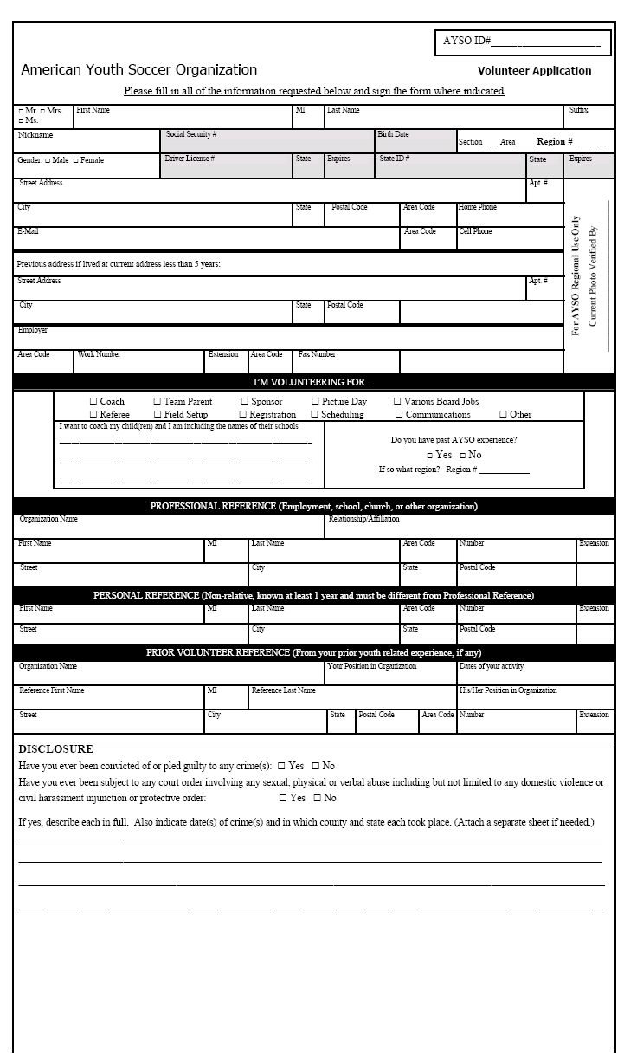
Chappaqua AYSO
Player Ratings – Divisions U6 and U7: 2003/2004 Season

Player Ratings for [Team]: _________________ Division: _____
Coach Name: ____________________ Phone #: ___________

1 - 2 – Weaker Player - Negative or no contribution to team, very passive, doesn’t always participate | 7 - 8 – Good - Positive contribution to team, skills better than average, continues to develop as a player.
3 - 4 – Below Avg. - Tries, enjoys playing, only small negative impact on team, passive. | 9 – Very Good - Among top players in Division, developing consistency w/ skills, aggressive.
5 - 6 – Average - Neutral to positive affect on team, inconsistent, always shows interest, passive at times. | 10 – Exceptional – Dominates game w/ skill, consistent, aggressive, has sense of game above peers, ability to play up.

 | Player Name  (First & Last) | Grade | Ball Handling | Kicking/  Passing | Participation | Aggressiveness | Attitude/  Sportsmanship  -, +, or N | Total | Comments
1.
2.
3.
4.
5.
6.
7.
8.
9.
10.
11.
12.

Skills to be Rated (1-10):
Ball Handling - Dribbling (w/ all parts of foot), trapping (w/ feet, body & chest), ball control.

Kicking/Passing - Control kicking, shooting, chip shots, ground shots & volleys. Use of both feet. (Downgrade for toe kickers.)
Use of either foot to effect an accurate pass. Use of all parts of foot.

Participation - Willingness to engage and focus in team play. Action, reaction & game awareness.

Aggressiveness - Aggressive on both offense and defense, speed with & without the ball.

Attitude/Sportsmanship - Respect for officials, coaches, teammates & opposing players. (“Sore winner or loser”). Mark as +, -, or N for neutral

Total - Total of all individual ratings (4-40)

Comments - Should address player’s “coachability”, affect on team, willingness to learn, and anything else that
would help the Division Coordinator assemble balanced teams next season.

Chappaqua AYSO
Player Ratings – Divisions U8 through U16: 2003/2004 Season

Player Ratings for [Team]: _________________ Division: _____
Coach Name: ____________________ Phone #: ___________

1 - 2 – Weaker Player - Negative or no contribution to team, very passive, doesn’t always participate | 7 - 8 – Good - Positive contribution to team, skills better than average, continues to develop as a player.
3 - 4 – Below Avg. - Tries, enjoys playing, only small negative impact on team, passive. | 9 – Very Good - Among top players in Division, developing consistency w/ skills, aggressive.
5 - 6 – Average - Neutral to positive affect on team, inconsistent, always shows interest, passive at times. | 10 – Exceptional – Dominates game w/ skill, consistent, aggressive, has sense of game above peers, ability to play up.

 | Player Name  (First & Last) | Grade | Ball Handling | Kicking/  Passing | Ability to play  w/in Position | Aggressiveness | Attitude/  Sportsmanship  -, +, or N | Total | Comments
1.
2.
3.
4.
5.
6.
7.
8.
9.
10.
11.
12.

Skills to be Rated (1-10):
Ball Handling - Dribbling (w/ all parts of foot), trapping (w/ feet, body & chest), ball control.

Kicking/Passing - Control kicking, shooting, chip shots, ground shots & volleys. Use of both feet. (Downgrade for toe kickers.)
Use of either foot to effect an accurate pass. Use of all parts of foot.

Ability to Play
within Position - Action, reaction & game awareness. Ability to stay in position, rather than roaming all over the field.

Aggressiveness - Aggressive on both offense & defense, speed with & without the ball.

Attitude/Sportsmanship - Respect for officials, coaches, teammates & opposing players. (“Sore winner or loser”). Mark as +, -, or N for neutral

Total - Total of all individual ratings (4-40)

Comments - Should address player’s “coachability”, affect on team, willingness to learn, and anything else that
would help the Division Coordinator assemble balanced teams next season.

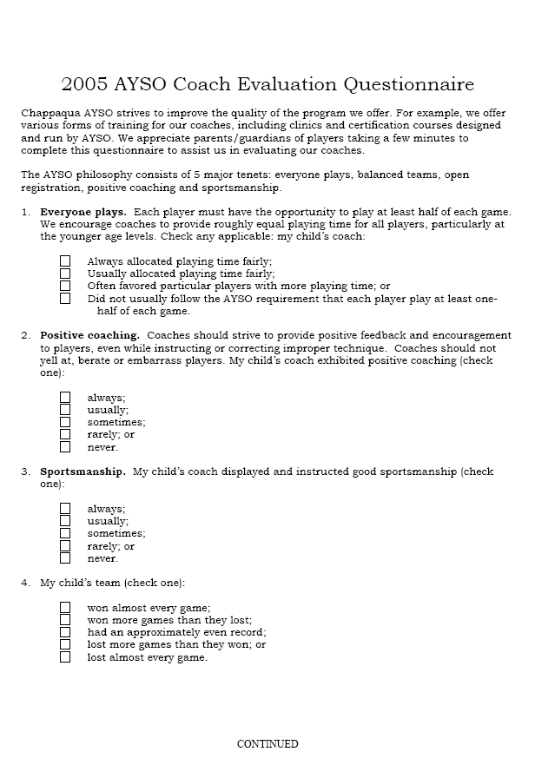
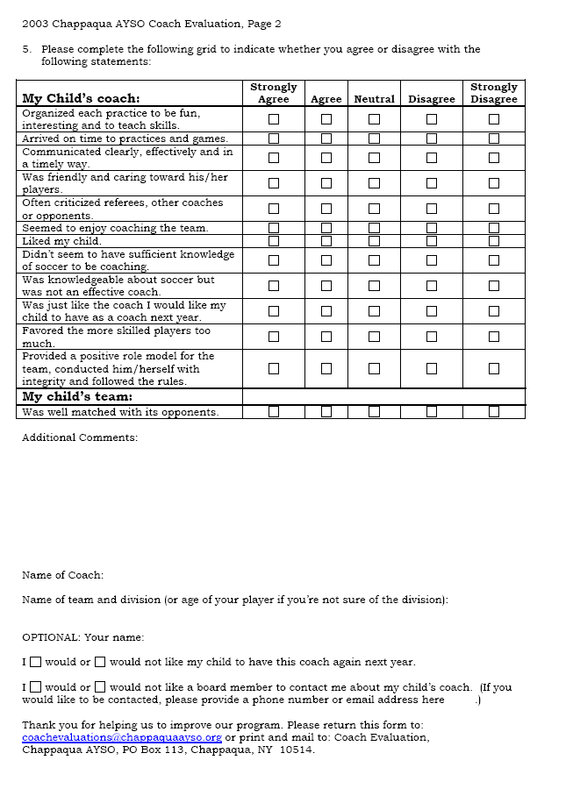
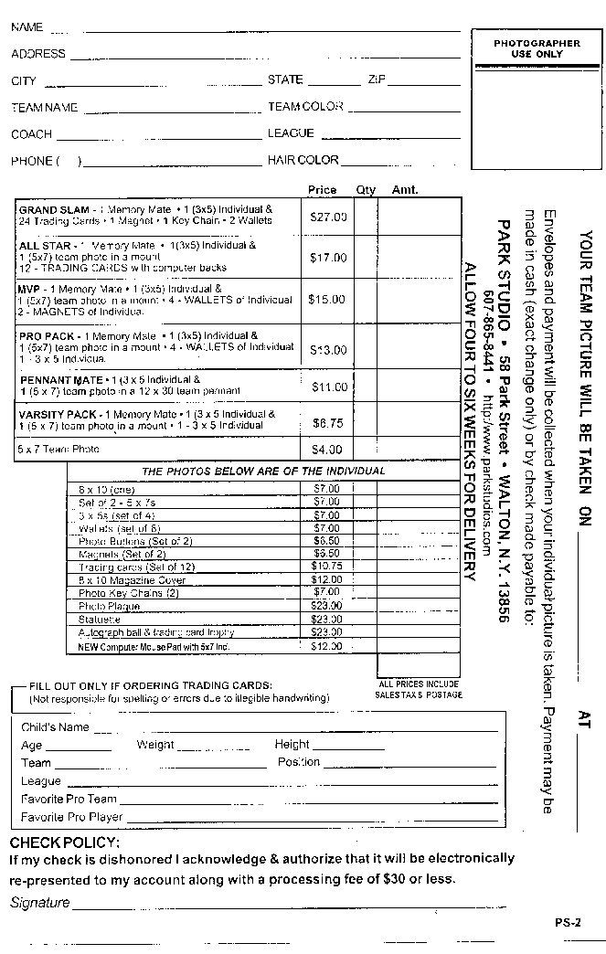

PLAYER REGISTRATION
2005/2006 Fall-Spring Season
Registration Form Collection at Town Hall
Saturday, April 30th from 9:30am to 12:30pm
Problems: Please email if you get stuck or would like assistance: dru@ivmost.com
Player Registration consists of these steps: (you can pay online now too!)
- entering information into the Chappaqua AYSO online system and printing forms
- entering information into the National AYSO online system (eAYSO) and printing player form(s)
- mailing forms to Chappaqua AYSO or hand delivering them on Registration Form collection day
Bottom of Form

Click here after completing steps 1 and 2

Registration Fees:
Postmark | 2005/2006  Full Season | 2005  Fall Only*
Thru 5/06/05 | $80 | $55
5/07 – 6/30/05 | $90 | $65
7/01 - 7/31/05 | $115 | $90
8/01 - 8/31/05 | $140 | $115
after 8/31/05 | $165 | $140

* Fall only option is available for children 8 and older.
=== no refunds given after June 30th ===
Special Spring 2005 Registration info for High School Players!

CHAPPAQUA AYSO EXTRA PROGRAM
The AYSO EXTRA program is available to all AYSO players who have the competitive desire for EXTRA soccer each week. Depending on the number of interested players, the EXTRA program in each age group may consist of individual teams or large groups. The program starts with children entering AYSO's U10 division (a two year grouping of children generally in 3rd & 4th grades). The EXTRA program consists of one extra practice during the week and an EXTRA game on Saturday afternoons. Additionally, EXTRA teams may be entered in one or more tournaments.
The EXTRA coaches in each age group, in conjunction with the AYSO EXTRA coordinator, will be responsible for formulating each age group's program based on the number of players, field availability, and level of interest. If there are a large number of players in an age group, the coaches and AYSO EXTRA coordinator will determine an appropriate number of teams to enter into the Area-wide EXTRA schedule. Depending on the number of players, it may be that NOT everyone plays in each game. Rosters for each game will be announced weekly. Commitment, desire, dedication, and attendance will be the primary factors considered.
The size and scope of the EXTRA program will be limited by field constraints and the availability of qualified coaches. Practices will be conducted or enhanced by professional trainers. However, it will remain a truly "EXTRA" program and all EXTRA players must participate fully on their regular AYSO teams.
Costs of the EXTRA program (such as trainers) will be borne by the participants.
In brief:
➢ EXTRA is open to all. There are no tryouts.
➢ EXTRA practices will be open to all players who sign up for the program.
➢ EXTRA players must play on their regular or core AYSO teams.
➢ Rosters for each game will be announced weekly.
➢ Coaches will be volunteer team parents, but professional trainers will conduct all practices.
➢ The expense of the trainers will be borne by the team, as will any optional additional expenses.
➢ EXTRA teams participate in an Area Wide schedule of play.
➢ Participation in at least 1 and probably 2 or more tournaments.
Contact: Tom Pile, Chappaqua AYSO EXTRA Coordinator
or your division coordinator

Tuesday, May 31, 2005

Joint CYSC/AYSO Statement on Travel Soccer
Starting May 31, 2005, the Chappaqua Youth Soccer Club (“CYSC”) will be conducting its tryouts for 2005-2006 travel teams for players in age groups U10 through U14, or, starting fourth grade through eighth grade in the Fall. The tryouts are open to all interested players. While space is limited on these teams at this time, not being selected by CYSC should not be taken as a final decree about playing soccer in Chappaqua, either competitively or recreationally. CYSC and Chappaqua AYSO (“AYSO”) encourage all persons not selected to continue playing soccer through AYSO and through the AYSO Extra Program.
The Extra Program provides players with an opportunity to continue their skills development and to play other towns’ Extra teams in a competitive environment. Any player interested in playing in the Extra Program will be given the opportunity to play for an Extra Program team, whether or not they attend the CYSC tryouts.
Best of luck in the tryouts!! Keep Kickin!!
Brian Rosen - Chappaqua Youth Soccer Club
David Perlmutter - Chappaqua AYSO
Tom Pile - Chappaqua AYSO Extra
posted by David at 12:52 PM 0 comments

Sunday, May 15, 2005

AYSO Extra and the Chappaqua Youth Soccer Club
Chappaqua Youth Soccer Club (CYSC)will be holding tryouts for players entering 4th grade and up soon. You can click on this link for the announcement. The flyer gives information on the dates, times and locations of each age and gender specific tryout. It also gives a brief description of the CYSC program and contact information. CYSC tryouts are open to all students attending Chappaqua Schools or living in the Town of New Castle. Players are selected for CYSC teams based on "ability" as perceived at the tryouts. The tryouts are open each year, and new players may supplant previous Club players. If you would like additional information on the Chappaqua Youth Soccer Club, it is available on their website www.chappaquasoccer.org.
Chappaqua AYSO also provides a travel soccer experience called AYSO Extra, which is supplemental to the regular or "core" program. All Chappaqua AYSO players in 3rd grade and up are eligible to participate in the Extra program. Extra players participate with their core soccer team in their Saturday practices and Sunday games. Additionally, there is a mid-week practice with their Extra team (usually run by a professional trainer) and a game on Saturday afternoon, usually around 4:00. There are no tryouts for Extra, so everyone “makes the team.” If there is more than one team in an age group, the teams will be balanced, just as we try to do in the core AYSO program. Extra teams play home and away games against AYSO Extra teams from other towns.
As in core games, each player at a game will play at least half a game, and no player will play a full game until all have played at least three quarters of the game. Depending on the number of interested players, the Extra program in each age group may consist of individual teams or large groups. The Extra coaches in each age group, in conjunction with the AYSO Extra coordinator, will be responsible for formulating each age group's program based on the number of players, field availability and level of interest. If there are a large number of players in an age group, the coaches and AYSO Extra coordinator will determine an appropriate number of teams to enter into the Area-wide Extra schedule. If there are more players than can fit on the number of Extra teams in the age group, the coaches will rotate the players through the game schedule so that no child is left out and every child is able to participate in Extra games.
There is a supplemental charge to players in the Extra program to cover the cost of trainers and a separate uniform, if necessary. This typically is about $100-150 per player per season. If you would like additional information on AYSO Extra, contact Tom Pile, AYSO’s Extra Coordinator at tpile@audible.com.
Both Chappaqua Youth Soccer Club and AYSO provide travel soccer experiences for your kids. Both organizations want your child to know that everyone attending the Soccer Club tryouts will be able to play travel soccer. Some will play with CYSC, others with AYSO Extra. Your child does not need to attend the CYSC tryouts to play AYSO Extra. When schedules and field space allow, CYSC and AYSO will try to coordinate mid-week practices, to facilitate carpooling and peer group interaction.
Chappaqua AYSO neither sponsors nor endorses the Chappaqua Youth Soccer club, but is providing this information for those that are interested, and because both AYSO and CYSC are interested in providing the best possible programs in accordance with their respective philosophies.
posted by David at 3:01 PM 0 comments

