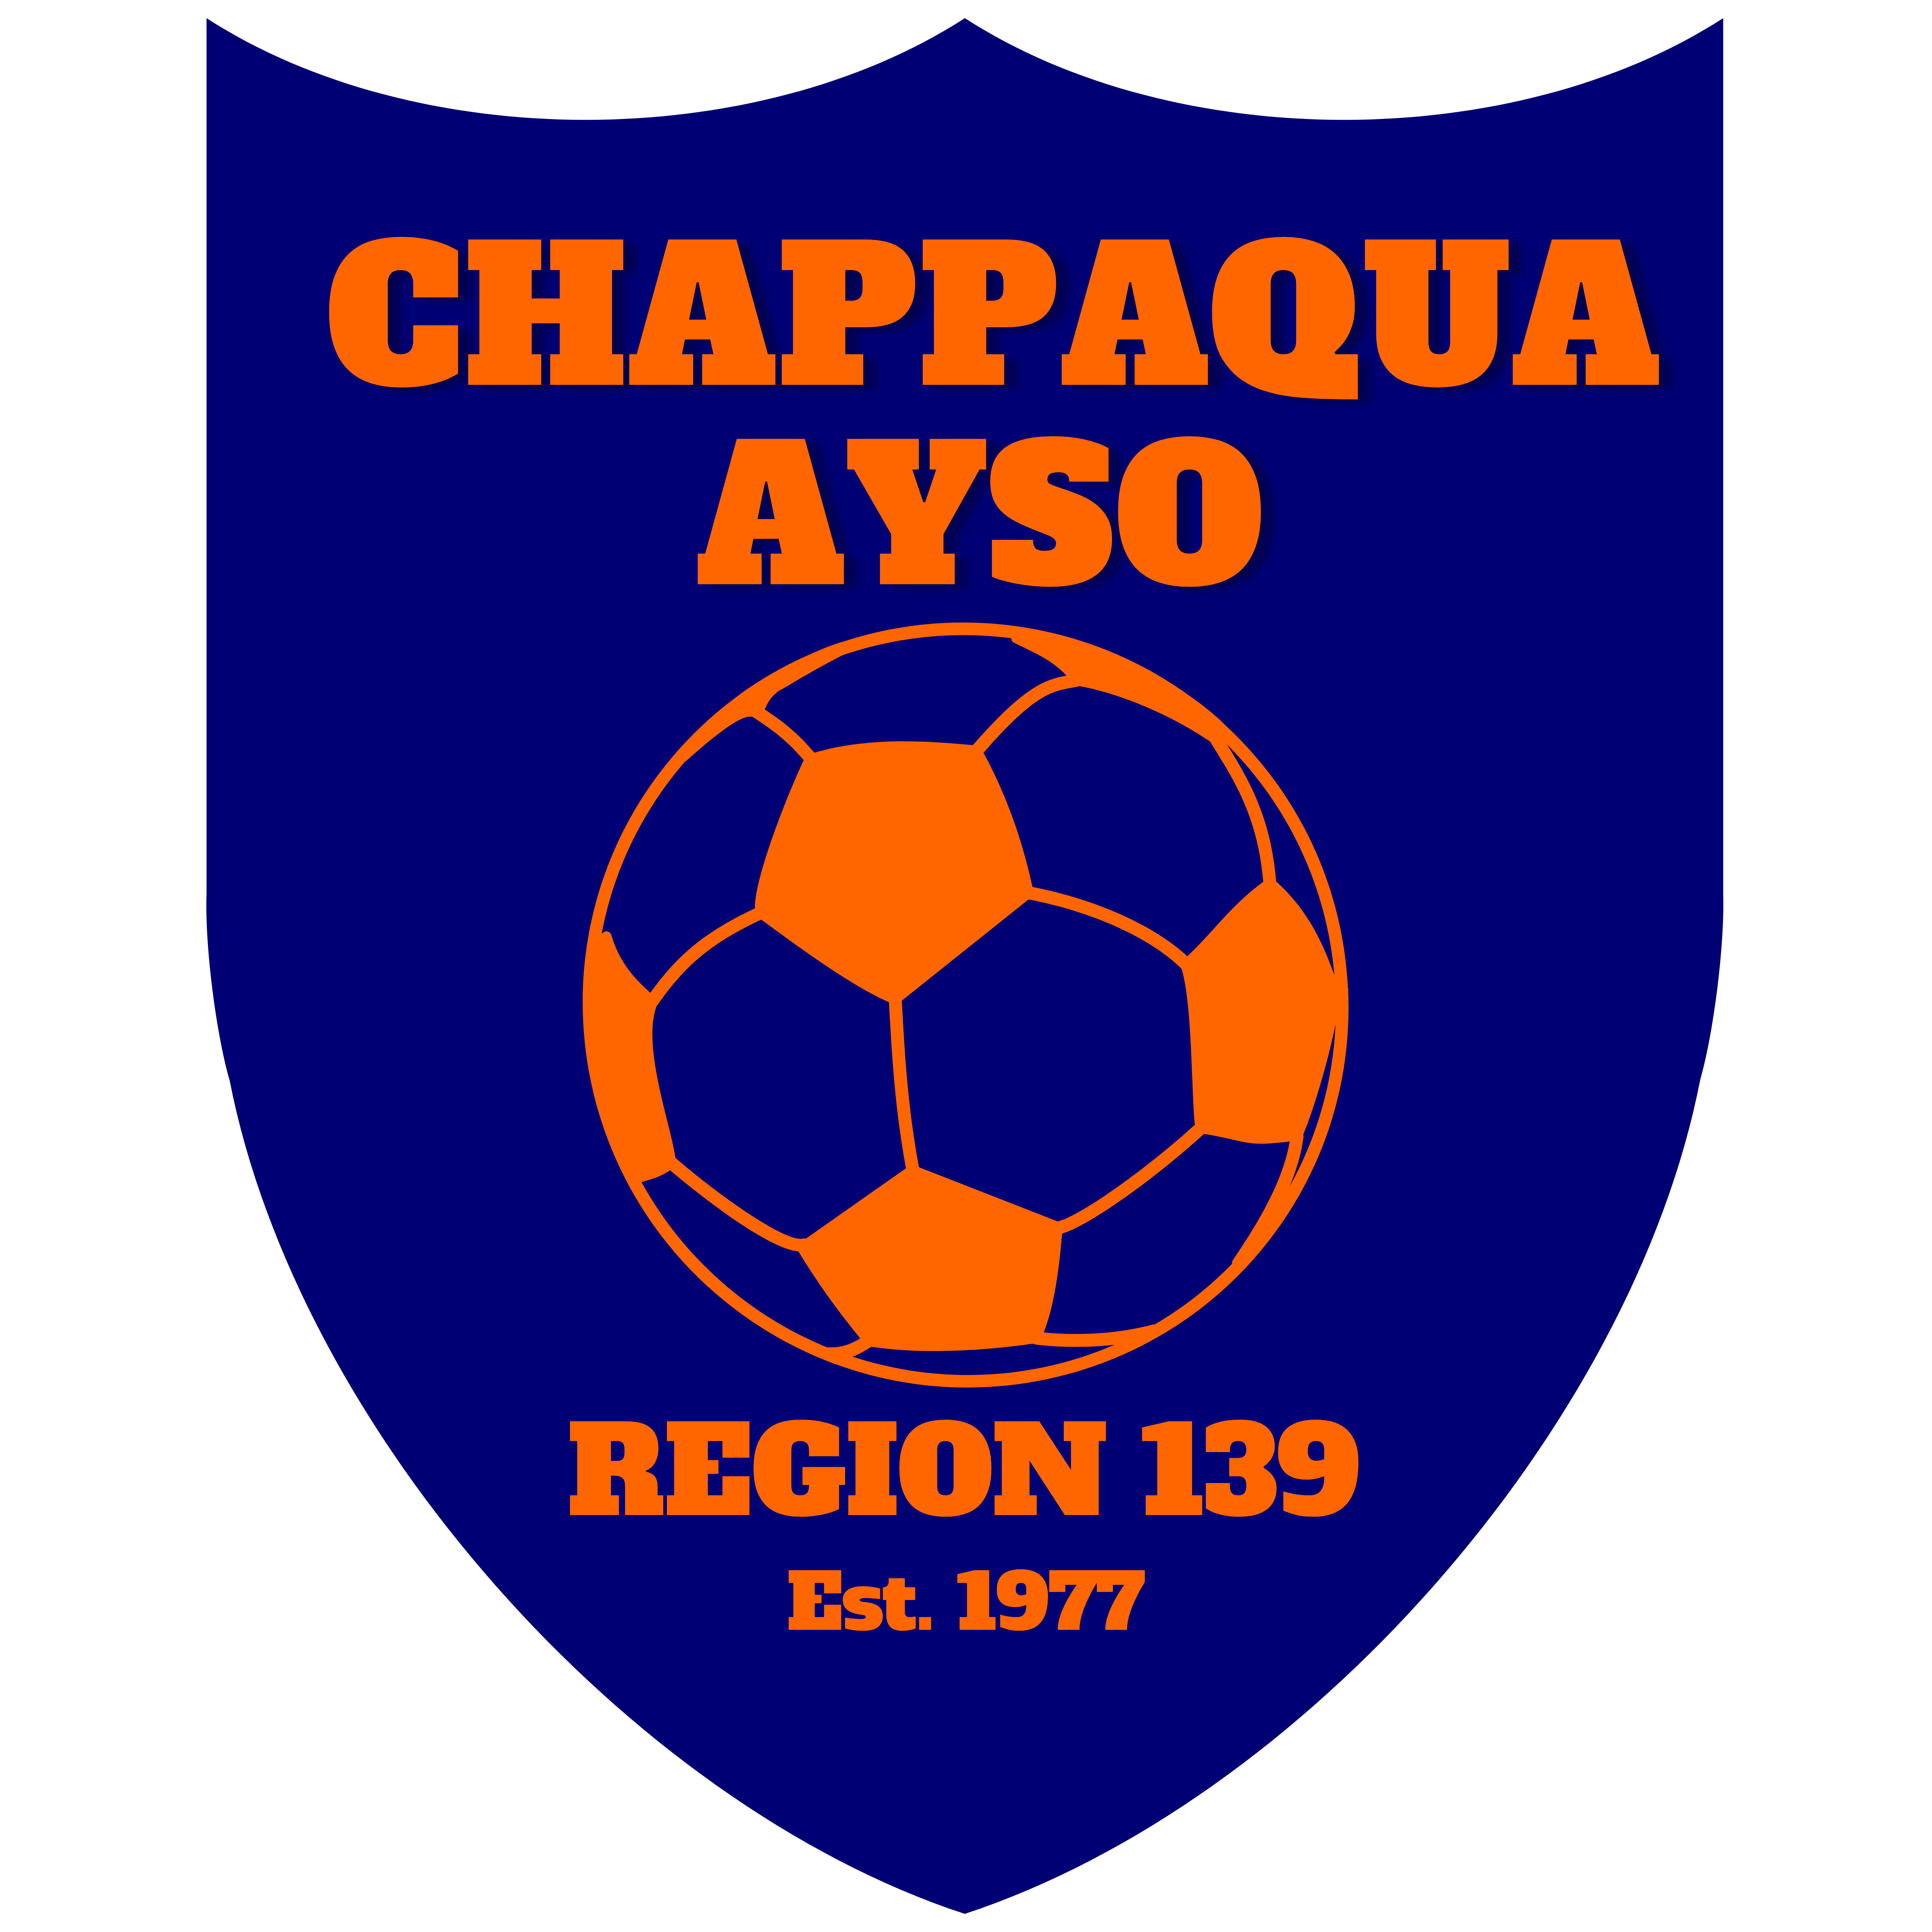
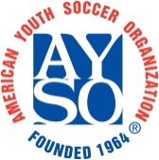
Fall 2019 Coaches Information
Chappaqua AYSO
Section 3, Area 3T, Region 139
www.chappaquaayso.org

Registration and Training Requirements:
- Instructions on http://chappaquaayso.org/volunteer-registration-on-blue-sombrero/
  - Apply as a new/returning adult volunteer
- Safe Haven certification
  - On-line webinar: http://www.aysou.org/ Sign in using Blue Sombrero credentials
  - Only need to do once
- Age-specific Coach’s training
  - Sign up for Live course on : http://www.aysou.org/
  - Only need to do once per age-group (U6, U8, U10, etc)
  - Future class dates TBA
- CDC Concussion Awareness
  - Follow instructions on http://chappaquaayso.org/coaches/
  - Must be done even if you took the town’s Concussion course in the past

Schedule:
- Practices and games start September 1; season ends November 17;
  - Get game schedule from your Division Coordinator.
- Be at your field 15 minutes early to prepare field (goals/sandbags/cones); prepare training plan night before (resources: coaches manual, our website, AYSO website)

Uniforms and Equipment bags: Check equipment bags and advise Division Coordinator if you need:
- First Aid kit, Ice packs, pinnies, cones
- Zip Ties for goal nets
- Contact the Equipment Manager for replacement / missing equipment

Safety:
- Sandbags on ALL goals –NY State law requires all goals be “anchored”
- Shinguards UNDER socks against the skin
- Cleats - no metal or sharp studs
- NO jewelry of any kind, including taped-over earrings or bracelets (ONLY exception is for medical alert bracelets, which must be taped over)
  - Lightning & Thunder: "If you hear it, clear it. If you see it, flee it." Play is suspended for 20 minutes.
  - If the town closes the grass fields then we are cancelled for that timeframe. No more town vs school.

Changes to the Laws of the Game, 2019:
- http://chappaquaayso.org/laws-of-the-game-changes-march-2019/

Weekly responsibilities:
- U12 and above: Contact opposing coach during week to confirm game & exchange contact info. Report game results into scheduling system.
- Rain-outs called prior to game or at field: Contact Division Coordinator and Referee Administrator Rob Catarella (rcatarella@gmail.com) immediately.
- Clear goals and sandbags off field if last game of day: http://chappaquaayso.org/goal-storage/
- Required on all fields. HGHS example:

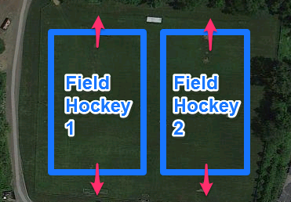
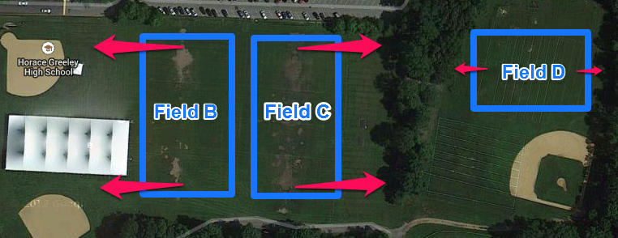

Other:
- Coaches: no sunglasses
- Collect signed Player Participation Form and keep in your equipment bag – must have with you every week; assistant coaches should have a set too
- Manage blowouts
  - Recognize early and employ strategies
  - Put scorers on back line and don’t press, only use weak foot, only shots from outside the box, only shots from players who haven’t scored
  - Trade players to balance game
- No heading the ball for U12 and below.
- U8 and above: Parents on opposite side of field from team and coaches
- Directions to fields: http://chappaquaayso.org/fields/

Referees:
- Most referees are children. DO NOT challenge the referees’ calls. Direct your concerns to the Referee Administrator Rob Catarella (rcatarella@gmail.com) after the game.
- Remind your parents
- Become a referee! We train referees age 12 and up: http://chappaquaayso.org/referees/

Photo Day: TBD

Free, Additional Training:
- Run by the upper division trainers
- Wednesdays, 4:30-6:00pm, Grafflin
- U10 and younger
- Includes separate breakout Goalkeeping skill development

Online resources:
- Weather Page: http://chappaquaayso.org/weather/
- Facebook: http://facebook.com/chappaquaayso
- Twitter: http://twitter.com/chappaquaayso
- AYSO National: http://ayso.org/
- AYSO training classes: http://www.aysou.org/

Contacts:
- Email addresses on http://www.chappaquaayso.org/Officers.asp

